27 August 2025

The Queensland Productivity Commission
PO Box 12078
George Street
BRISBANE QLD 4003

QIDAN’s submission on the interim report “Opportunities to Improve Productivity of the Construction Industry”
Coordinated by Queensland Advocacy for Inclusion (QAI), QIDAN is a group of organisations funded under the Queensland Disability Advocacy Program (QDAP) to provide individual advocacy assistance to Queenslanders living with disability. The members of QIDAN offer various independent disability advocacy assistance across Queensland, bringing substantial frontline experiences supporting people with disability navigating housing challenges across Queensland.
The Queensland Government data shows that on 31 March 2025, the Social Housing Register had 28,486 housing register applications, with 12,776 of these applications (or about 45%) being household applications including persons with identified disability. These figures, and QIDAN data below, highlight the scale and urgency of housing challenges faced by people with disability.
In 2024, housing and tenancy related matters were the most common non-NDIS issues that advocates assisted clients with, accounting for almost 10% of all advocacy provided over the year. The number of advocacy matters, and the amount of time spent on these matters, also grew across the year. In addition, through QAI’s coordination of Disability Advocacy Pathways information and referral service, we responded to 82 housing related enquires, comprising 14% of all Pathways referrals.
A quick note on language: we use “Livable Housing Design Standards” and “accessibility standards” interchangeably as they have the same design requirements.
It is based on our expertise that we therefore refute the Queensland Productivity Commission’s (QPC) preliminary recommendation 11 which states that “Unless it is demonstrated through consultation that energy efficiency and accessibility standards made as part of the NCC 2022 provide a net benefit to the Queensland community, the Queensland Government should amend the Queensland Development Code to opt-out of these provisions (that is, make them voluntary)”.
QIDAN’s position is based on the following reasons:
- The implementation of the National Construction Code’s Livable Housing Design Standard not only enhances the productivity of the housing industry, but it improves overall economic efficiency. This is confirmed by new research by the Melbourne Disability Institute, which shows that when the full benefits and full costs of LHDS are properly accounted for the benefit-cost ratio is at least 1.7.
- The “significant and growing cost” to implement Livable Housing Design Standards argued in the interim report have been already refuted by the Disability Royal Commission into Violence, Abuse, Neglect and Exploitation of People with Disability (‘the DRC’). After noting that no qualitative factors have been ‘quantified or monetised’, the DRC made recommendation 7.35, calling for an immediate adoption of mandatory Australian Building Codes Board Livable Housing Design Standards (LHDS) for all new dwellings.
- The Queensland Government accepted in principle DRC recommendation 7.35 and noted it is expected 100% of homes will comply with the LHDS, commencing 1 October 2023. It has also committed to “build 50 per cent of all new social housing to meet Livable Housing Design standards at Gold or Platinum level”.
- Similarly, the NDIS Independent Review recommended that all Australian governments should commit “to sign-up to the Livable Housing Design Standards in the National Construction Code” (Action 9.11).
- The DRC received submissions at 37 public hearings, held private sessions with 1,785 participants and received 7,944 submissions. The NDIS Independent Review received 3,976 submissions. While the initial consultation for this inquiry held 52 stakeholder meetings and received 80+ submissions. We must listen to what people with disability have been asking for.
- Articles 19 and 28 of the Convention on the Rights of Persons with Disabilities (CRPD) require States Parties (Australia being one of them) to recognise the rights of people with disability to live in the community, with choices equal to others, and to have adequate housing.
- In our experience, the economic, social and mental impacts and costs related to supporting people to navigate house modifications, to access Specialist Disability Accommodation, and to secure long-term accessible social housing, can be much higher or even costless, compared to the necessary investment to accessible standards that benefits everyone.
In conclusion, we refer to the Melbourne Disability Institute submission to this inquiry and support their argument that “the implementation of the Standard in Queensland not only assists productivity but also supports broader government priorities and improvements in social welfare”.
Therefore, we refute recommendation 11 of the QPC’s interim report. Instead, we call on the Queensland Government to maintain mandatory implementation of Livable Housing Design Standard, as well as on the implementation of the Queensland Government’s commitment to build 50 per cent of all new social housing to meet Livable Housing Design standards at Gold or Platinum level.
If you have any questions or would like to discuss our requests further, please contact me
via email (caitlin@qai.org.au) or on 07 3844 4200 and I can arrange a time to speak with
you.
Yours sincerely
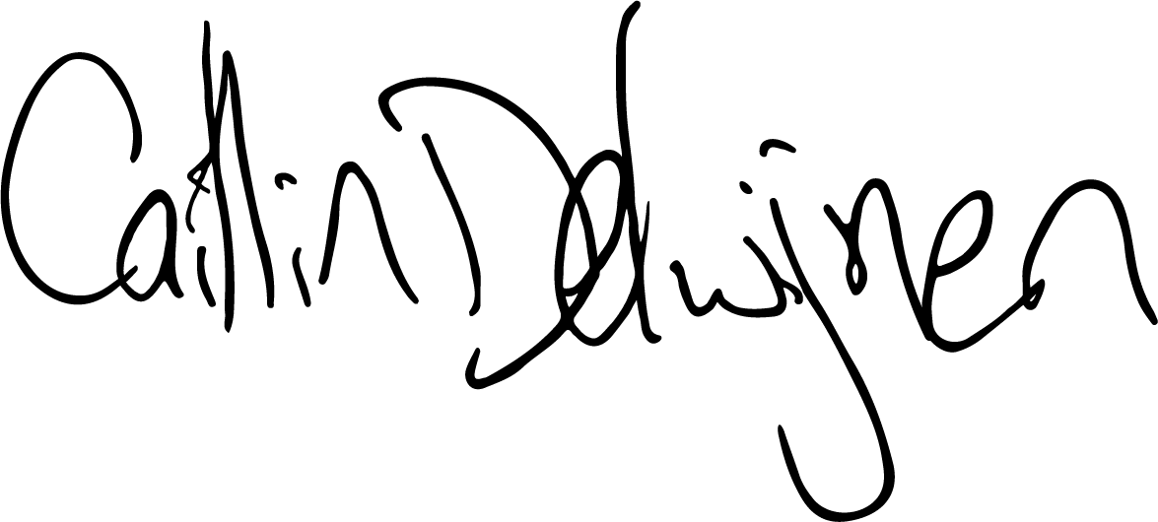
Caitlin de Cocq van Delwijnen
Principal Advocate, Queensland Advocacy for Inclusion
On behalf of the Queensland Independent Disability Advocacy Network (QIDAN)

https://www.data.qld.gov.au/dataset/social-housing-register
https://disabilitypathways.org.au/
QPC Opportunities to Improve Productivity of the Construction Industry, Interim Report Summary, Page 48.
S-022 Melbourne Disability Institute (PDF, 360.47 KB)
Economic Advice Prepared To Assist Responses To The Queensland Productivity Commission On The “Net Benefit To The Community” Of The National Building Code Regulation To Achieve Accessible Housing Prepared by Professors Rob Carter and Bruce Bonyhady, 26 August 2025.
https://www.families.qld.gov.au/_media/documents/disability/queensland-government-response-disability-royal-commission.pdf, page 81.
https://www.ndisreview.gov.au/sites/default/files/resource/download/working-together-ndis-review-final-report.pdf, page 155.

