Make Disability Count in Queensland - inclusion, rights and access
An inclusive Queensland is important for all Queenslanders. That why thirtyfour (34) disability organisations are coming together as the Queensland Disability Alliance to host the ‘Queensland State Election 2024 Disability Online Forum’.

As a disability alliance we want to make sure disability is front and centre at this 2024 state election.

1 in 5 Queenslanders live with a disability. Collectively, our organisations represent the breadth of the Queensland disability, advocacy, health, mental health, education and community services sectors. We represent people with disability, their families and carers and we share a common goal: building a more inclusive Queensland where everyone thrives.

The disability and community services sector isn’t just vital for people with disability; it's one of the fastest-growing sectors in Australia, driving significant contributions not only to the disability community but to the broader economy as well.

We acknowledge and address the needs and supports for the diversity of the disability community, including First Nations people with disability, people from Culturally and Linguistically Diverse backgrounds, those living in regional and remote areas, women, LGBTIQA+ individuals, and children and young people with disability.
Collectively we are committed to the rights, social and economic participation of people with disability and their families and carers. We stand by the crucial role that the disability, community services, and mental health sectors play in driving Queensland's economic growth.
Our vision for a more inclusive Queensland demands a robust disability ecosystem, one that meets the needs of all Queenslanders with disability, including essential mainstream services like education, health, housing, justice, child safety, employment, transport, and disaster management.
We want to see action.
We’ve identified six priority areas where action is needed, and we are calling on all political parties to commit to these key areas, ensuring that our vision for an inclusive Queensland becomes a reality.
The Disability Alliance asks the next Queensland Government to commit to:

Foundational Support Service System
Build on the cross sector multi-stakeholder design work done to date in Queensland and use this as a platform to continue co-design of a connected system of support for people with disability.
Deliver required investment in a general and targeted foundational support service system to meet the first tranche June 2025 timelines and transitional reforms.
A general foundational support service system needs to deliver programs and activities that provide information and advice, capacity building, peer support, self-advocacy and disability employment supports.
A targeted foundational support service system needs to deliver home and community supports, targeted supports for people with psychosocial disability, early supports for families and children and transition supports for young people to live more independently.
Deliver a strong foundational support service system that is co-designed with people with disability, their families/carers and providers that will fill gaps in services and systems for both NDIS participants and people with disability not eligible for the NDIS.

Disability Reforms - Disability Royal Commission and NDIS Review
Implement Disability Royal Commission recommendations that have been supported by State in full, in part and in principle and subsequent commitments to NDIS including targeted supports to people access the NDIS to deliver the best outcomes for Queenslanders with disability.

Independent individual and systemic advocacy
Continued investment in independent individual and system advocacy across disability, health and mental health for people with disability to meet current unmet needs for advocacy.

Disability leadership and innovation
Investment in disability leadership and representation of people with disability, families and disability sector leadership to inform and deliver innovation.
Ensure Queensland gets its fair share of funding to deliver Information, Linkages and Capacity Building (ILC) programs tailored to the needs of the Queensland disability community.

Mainstream services
- Increase funding for community based mental health services to meet the needs of estimated 92,000 people currently missing out on services;
- Deliver investment in the training of workforce for mainstream Government departments to enable provision of inclusive, quality, accessible, and affordable services across housing, health, justice, disaster and emergency management, child safety, jobs, education and transport.
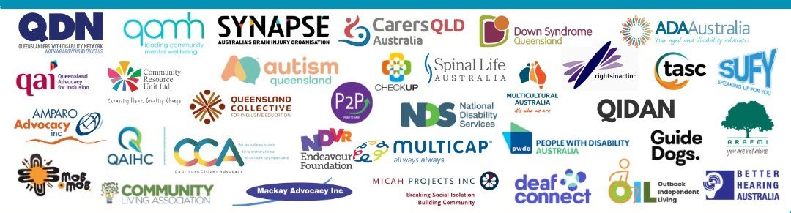
- Ensure the delivery of inclusive mainstream services through monitoring service and systems performance. Deliver oversight mechanism that includes people with disability and community and deliver public reporting on targets and outcomes including progress towards completion of recommendations of disability reforms.

Disability workforce and sector capacity
Grow, develop and maintain a skilled, trained and well supported, culturally inclusive disability, community, health and mental health workforce.
Grow the capacity, sustainability and resilience of the sector to deliver quality services and contribute to the economic outcomes of Queensland.

