2 April 2025
The Hon. Deb Frecklington MP
Attorney-General of Queensland and Minister for Justice and Minister for Integrity

By email: attorney.general@ministerial.qld.gov.au
Dear Attorney-General,
We are writing on behalf of the Aboriginal Family Legal Services Queensland,
ATSILS, Basic Rights Queensland, Brisbane Youth Service, Caxton Community
Legal Centre, Community Living Association, Equality Australia, Human Rights Law
Centre, LawRight, LGBTI Legal Service, Neighbourhood Centres Queensland,
Northside Connect, PeakCare, QCOSS, Queensland Advocacy for Inclusion,
Queensland Muslims Inc., Rights in Action, The Services Union, YFS, YFS Legal and Youth Empowered Towards Independence,
We refer to the independent review into the Human Rights Act 2019 by Professor Susan Harris Rimmer which was tabled in Parliament on 26 March 2025.
The report addressed a wide range of human rights including those arising out of housing needs, domestic and family violence, victims’ experiences, child detention, standards of living in remote areas, mental health and corrective services.
The report’s recommendations address the significant systemic issues involving children held in watchhouses, involuntary treatment in the mental health system, food insecurity in remote Queensland areas, preventative mental health and other matters. There is an emphasis on transparency and accountability in the legislative process and across government more generally. Three recommendations specifically address victims’ rights.
The report is lengthy, considered and complex, and is an important starting point in addressing the entrenched domestic violence, homelessness and significant disadvantage evident across Queensland. The recommendations deserve more than a cursory dismissal.

Many community legal centres, community service organisations and other Queenslanders contributed to the review process. These contributions extended significantly beyond the parameters of the rights of the victims of youth crime as contained in the Making Queensland Safer Act 2024, as do the recommendations of the review. We collectively express our significant disappointment that the government is unwilling to implement any of the recommendations because of changes to the law in one discrete area.



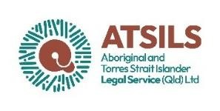





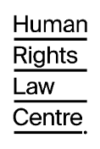




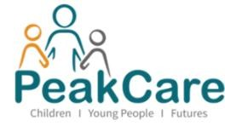







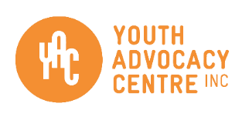


The
Human Rights Act

remains a fundamental part of the protections afforded to all
Queenslanders. The review was an important process in the continued protection
of the rights of all Queenslanders and we request an
urgent reconsideration

of the
decision of the government to not implement
any of

its recommendations.

Yours
faith
fully
,

Katherin
e

Hayes
,
CEO

Youth Advocacy Centre Inc

