Data Analysis of Housing / Tenancy Issues

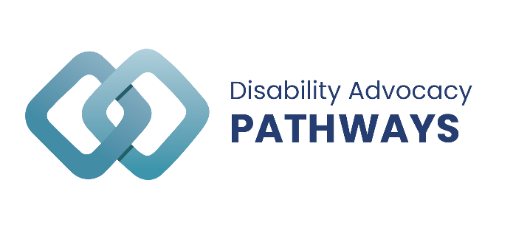

Report by the
Queensland Independent Disability Advocacy Network (QIDAN)

Hon Craig Crawford

14 September 2022

Introduction
Housing and Tenancy has been a key issue for people with disability accessing independent advocacy in Queensland. Since the beginning of the Queensland Disability Advocacy Program in January 2022 the most common reasons people have called us have been:

- NDIS,
- Housing and tenancy,
- Health and mental health,
- Access to goods and services, and
- Complaints about government services.

Experiences
Pathways received enquiries for a range of issues impacting people in private rentals, community house, government housing, hostels, supported independent living and other accommodation. Many people with disability who contacted Pathways reported a lack of financial resources, insufficient NDIS supports, experiences of violence, and limited access to homelessness services due to service capacity. As a result, people were stuck in hospital unable to be discharged, at risk of breaching bail or parole requirements without suitable accommodation and living in hostels with inappropriate and restrictive services.

The impact of the surge in demand in the Queensland rental market is clearly reflected in a variety of issues that people with disability engage Pathways for, in the private, public and community housing sphere.

From the Pathways services, the most common presenting issue that people with disability experienced in the private rental market include:
- Increases in rental prices, often to significantly more than the total Disability Support Pension per fortnight,
- Poor communication from landlords and lack of maintenance to the property,
- Seeking relocation due to living conditions negatively impacting health,
- Sale of property by the homeowner, and
- Real estate refusing to offer lease renewal.

Of particular concern was a trend where the issue related to family involvement and disputes surrounding private rentals for people with disability. This included:
- Selling or having the intention to sell the residential property without an alternative option for their family member with disability, or
- Enforcing landlord responsibilities and unnecessarily bills such as rates onto their family members with disability who is renting from them.

The majority of issues regarding Department of Housing involved:
- Significant waitlists, one report was a sole parent with disability currently couch surfing who has been waiting over 9 years,
- Difficulty with transfer applications to more appropriate accommodation and safety concerns,
- Concerns regarding living conditions exacerbating mental health conditions, and
- The Department not listening to concerns of renters and renters being fearful of making a complaint that may have potential negative repercussions.

Concerns raised regarding community housing include:
- Unsuitable and poorly maintained properties, and
- Disrespectful and dismissive providers when concerns are raised.

People living in Supported Independent Living (SIL) arrangements reported issues:
- Being asked to vacate the SIL as they did not want to use the same provider for all of their supports,
- Receiving conflicting information verbally and in the contract, and
- The provider deciding they were ‘no longer appropriate’ to provide support to the person with disability due to the complexities of the situation.

The 2021 – 2022 Queensland Floods has an ongoing impact for people contacting Pathways. People have reported to Pathways that they have ongoing issues relating to plumbing and mould that have not been rectified by landlords. In some instances, individuals have been unable to break their lease and find alternative accommodation. At the time of flood, many people lost all of their possessions and often had nowhere to go, especially if they had animals. In many cases, community legal services and housing support services were at capacity and unable to assist everyone requiring assistance.

Data
In January 2022, Queensland Advocacy for Inclusion (QAI) established Disability Advocacy Pathways ‘Pathways’. Pathways is an information and referral service that assists Queenslanders with disability, their family, friends, and carers to find advocacy services to suit their needs and location.

Between 05 January 2022, and 31 July 2022, Pathways has provided 450 information and referral services. This report provides an overview of the housing/ tenancy information and referral services provided by Pathways.

People from all over Queensland call QAI’s Pathways service to request disability advocacy. The most common problem for people seeking disability advocacy Statewide was NDIS. The second most common problem was housing (18.2%). Requests for disability advocacy for housing and tenancy problems are steadily increasing. Of the 450 information and referral services provided by Pathways, most callers experienced homelessness, financial disadvantage and/ or domestic and/ or family violence.
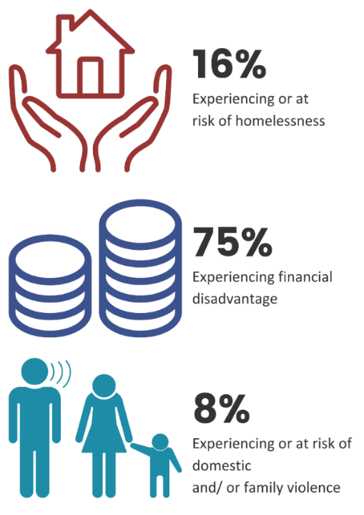

NDIS access, financial, and legal issues were reported as the key secondary issues in 49 instances when people had housing/ tenancy concerns.
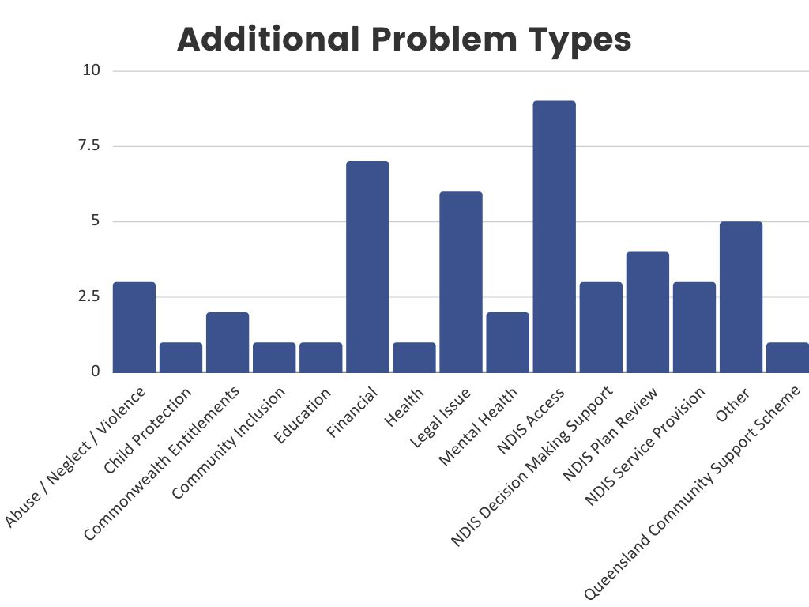
A total of 82 services were provided for ‘housing/ tenancy’ problems over 79 hours. Over 36.5% of housing/ tenancy inquiries were referred to advocacy organisations. \
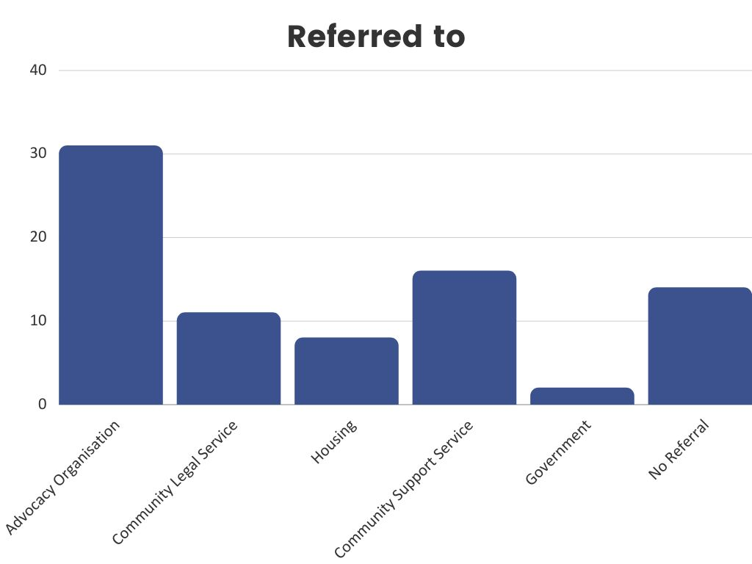

Advocates in Queensland assist with a range of issues experienced by people with disability. Data from the organisations funded though the Queensland Disability Advocacy program (QDAP) has been analysed to inform this report.

Between January and May 2022, a total of 885 advocacy services were provided to Queenslanders with disability. Following issues with the NDIS, housing/ tenancy was the highest problem type at 9.7% of all services (86 individual services). This equates to over 1055 hours of advocacy support in five (5) months.

Almost 56% of people who contacted QDAP organisations regarding housing/ tenancy issues were NDIS participants.
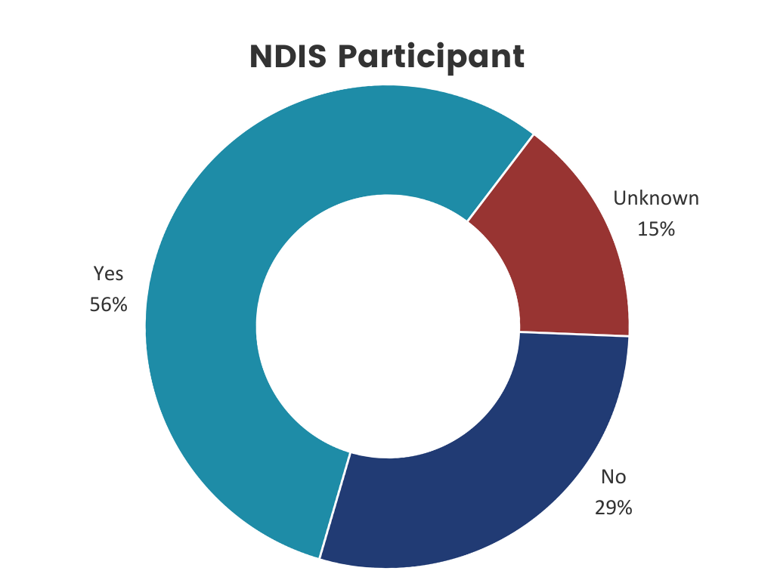

The majority of housing / tenancy advocacy services were provided to people in the Brisbane service region. This was followed by the service region of Townsville and Maroochydore and the specialist cohorts for Aboriginal and/ or Torres Strait Islander and culturally and linguistically diverse peoples.

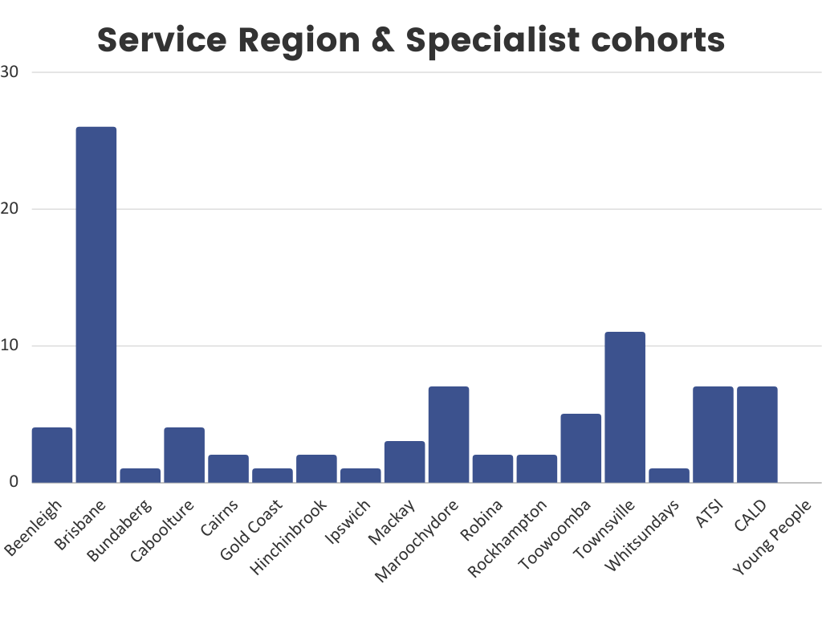

Over Fifty-three percent of individuals who received housing/ tenancy advocacy identified as male. Almost 14% of people receiving housing/ tenancy advocacy identified Aboiriginal and/ or Torres Strait Islander while 15% identified as cultrally and lingusitically diverse. Almost 5% reported experiencing domestic and/ or family violence.

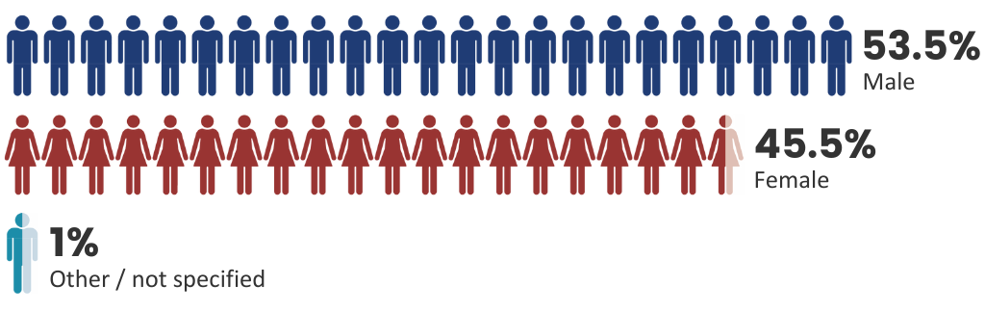

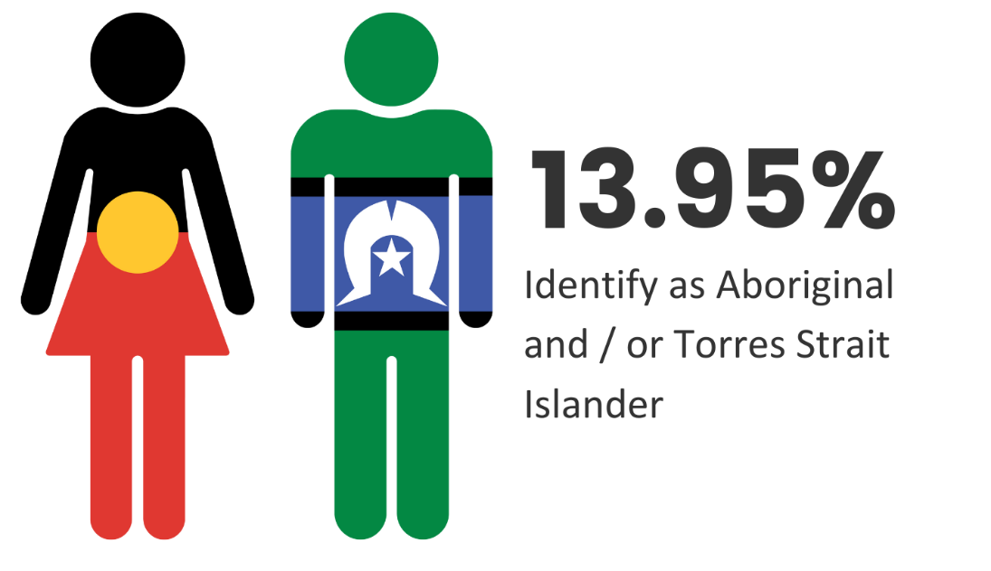

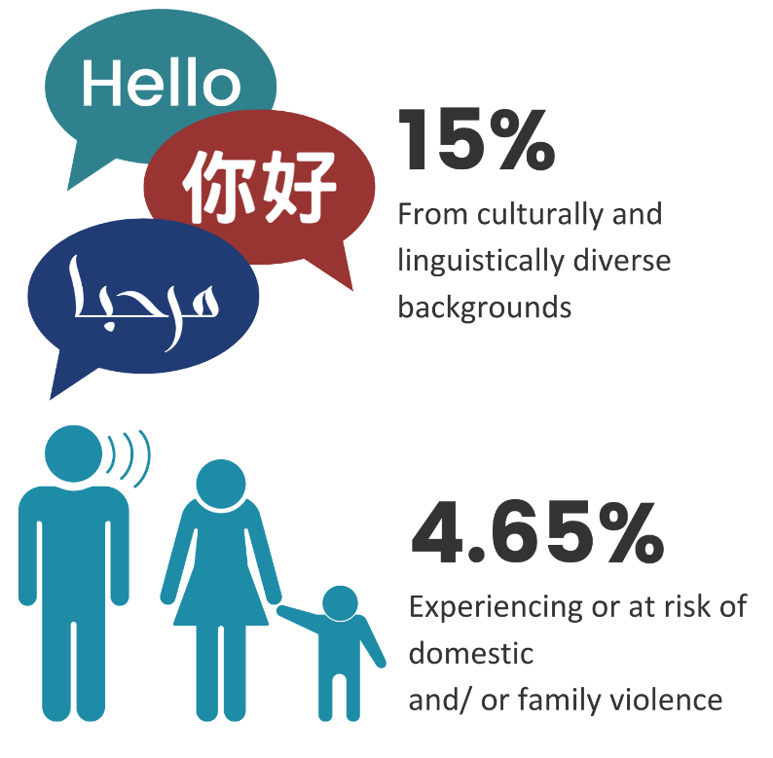

Most people receiving advocacy for housing / tenancy issues were aged between 30 and 69 years of age.

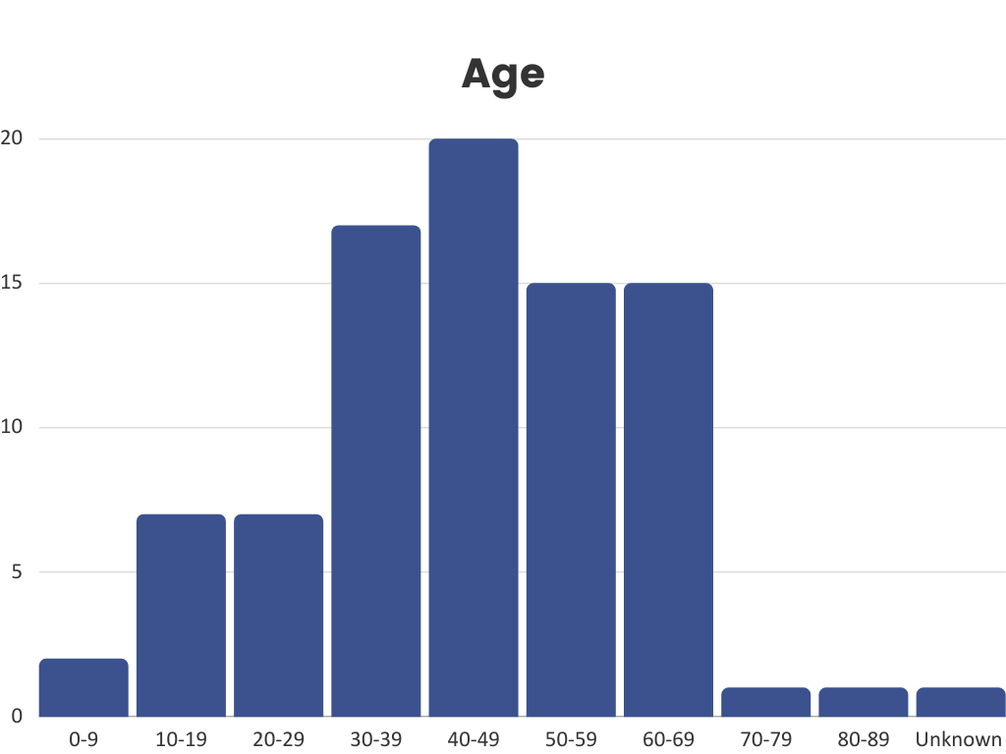

Advocacy was provided to people with a range of disabilities for housing/ tenancy issues. People living with Intellectual impairment, physical disability, and psychosocial disabilities psychosocial disability, were the most represented.

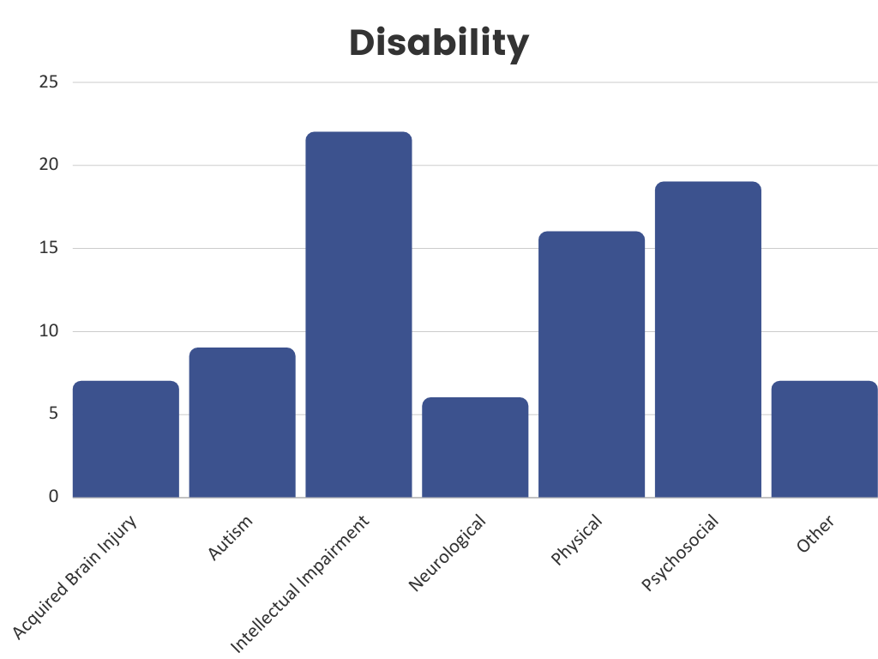

Case Example
Julie* contacted Pathways with concerns about her accommodation. Julie advised that she was living in a hostel and has been disappointed with the care, which is impacting her mental health, stating that living there is “like jail”. She states that they don’t provide what is advertised, for example, her bi-polar medication is to be taken ‘as required’ however, the hostel withholds the medication. Julie advised that if she is late for meals, she isn’t able to get food and when she has raised concerns about other residents to management, nothing is done about it. Julie was referred to the local advocacy organisation to assist with these concerns and to explore other support options such as applying for the NDIS.
*Name has been changed to protect confidentiality.

