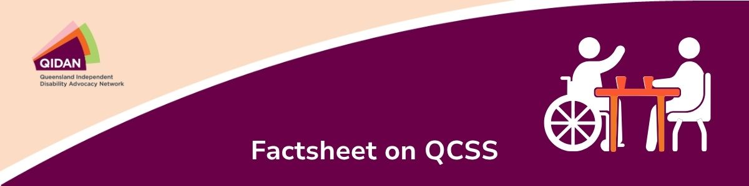
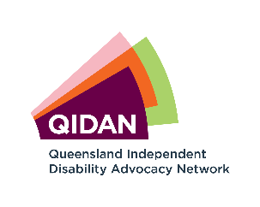

What is the QCSS?
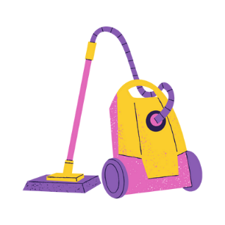
The Queensland Community Support Scheme (QCSS) can fund small amounts of support (about 5 hours a week) for a limited period (usually less than 12 months) for people with disability in Queensland. QCSS encourages people’s engagement with their community and independent living.
QCSS can help you at home, with things like:
- household chores like cleaning and laundry
- personal care
- essential yard maintenance
- making appointments and managing household paperwork
- building confidence in using internet supports


QCSS can also help you in the community, with things like:
- buying groceries
- accessing mental and physical health support services
- attending appointments
- helping with participation in social activities

Can I access the QCSS?
The QCSS Access Point will assess whether they can help you live independently and access other services quickly.

To be eligible to apply, you must:
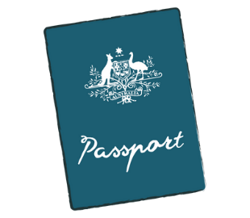 | 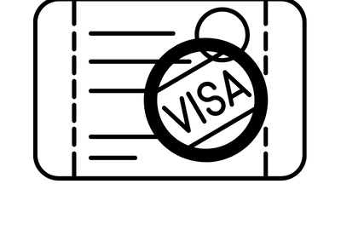 |  |  | 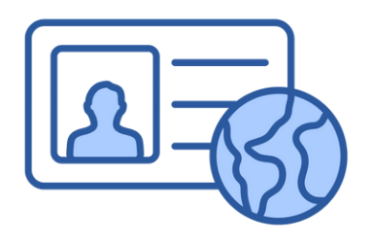
be a citizen or a permanent resident of Australia, living in Queensland permanently | OR | hold a Special Category Visa (subclass 444) (SCV) and a current Australian Medicare Card | OR | hold a Refugee or Humanitarian Visa

You cannot apply to the QCSS if you:
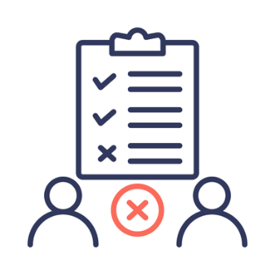
- are 65 years or older, or an Aboriginal or Torres Strait Islander person who is 50 years or older
- are in or leaving institutional care facilities
- do not meet the QCSS Visa requirements
- are eligible for NDIS supports
If you are unsure of your NDIS eligibility or the QCSS Access Point requests a letter from NDIS, you can seek help from an advocate to talk to the QCSS Access Point.

What happens if I get access to QCSS?
If the QCSS Access Point decides you are eligible, they will connect you to a service provider, who will help create a support plan within two weeks. Sometimes it may take longer to find a local service provider who is accepting new participants.
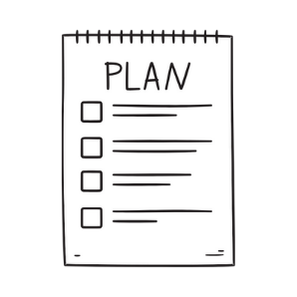
Your support plan will include:
- what type of supports you get
- how much support you can get every week
- how long QCSS will fund supports for you
The plan will also include any applicable fees you may need to pay for supports. Fees may vary among service providers but are limited by a fee scale that factors your income level. You may review your support plan with the Service Provider and make changes as required.
To apply, contact the QCSS Access Point:

- By phone at 1800 600 300 during weekday business hours
- Online, at www.serviceavailabilityregister.com.au
- If you are already connected with a service provider, use the contact details provided by them.

What happens if I don’t get access to QCSS?
If the QCSS Access Point tell you that you can’t get access to the QCSS, you may speak to an advocate. The advocate will help you understand the QCSS Access Point’s decision and may be able to help you talk to the QCSS Access Point.



To inquire about other supports and services in your community, speak to Pathways. Pathways is an information and referral service for people with disability, their families, and their support networks. You can contact Pathways on:
1800 130 582
pathways@qai.org.au
www.disabilitypathways.org.au

Note: This publication is for general information only. It must not be relied on as legal advice. You must seek legal advice about your own particular circumstances.

