QIDAN Summary of Recommendations to the Disability Discrimination Act 1992 Review

November 2025

No more excuses to discriminate
We welcome the Australian Government’s and the Attorney-General’s commitment to upholding the rights of people with disability and ensuring anti-discrimination laws work for people with disability. We also welcome the focus of the Disability Discrimination Act 1992 Review on the implementation of the Disability Royal Commission into Violence, Abuse, Neglect and Exploitation of People with Disability final report and its 15 recommendations relevant to the Disability Discrimination Act 1992. Advocates contributed to the DRC in several ways, providing advocacy to people with disability involved in the DRC, assisting people with disability to access and share their experiences, preparing submissions and attending hearings. We remained cognisant of both the pain and harm caused to people with disability reliving traumatic experiences, and the courage and resilience of Queenslanders. We are pleased to see that people’s stories have resulted in the DDA Review, and that steps are being taken towards a future free from discrimination.
The key role of QIDAN’s advocates is to uphold the rights, interests and wellbeing of people with disability, addressing discrimination and barriers. We support people who are engaged with discriminatory systems such as education, housing, employment and health, including assistance to lodge a complaint to the Queensland Human Rights Commission or to the Australian Human Rights Commission. The QHRC reports that impairment or disability discrimination continues to be the most commonly accepted complaint. The DRC also showed that people with disability are more likely to experience violence and abuse compared to others. When this abuse happens in public, it can incite more hatred and abuse with devastating consequences for the person and broader community.
Many of our recommendations are based on the DRC proposed reforms and our community has been eagerly waiting them. No more excuses to discriminate against people with disability.

Recommendations
- Include the Convention on the Rights of Persons with Disabilities in the objects of the DDA. This should expressly require the DDA is interpreted in line with international treaties.
- The definition of disability must use respectful and affirming language and reflect the rights of people with disability, and it must use language inclusive of people with neurodiversity. We recommend the removal of references to outdated and inappropriate language such as 'malfunction', 'malformation' and 'disfigurement' (in paragraphs (e) and (f) of the definition).
- Remove the direct discrimination comparator test from the DDA, as in the DRC recommendation 4.23.
- Allow claims to be brought for multiple or combined protected attributes, strengthening the DDA and making it compliant with article 5 of the CRPD.
- Reverse the burden of proof in the DDA. This means the person with disability must demonstrate the attribute and area and the respondent or duty holder must demonstrate that the unfavourable treatment was not because of the person’s disability and / or another protected attribute, as in the DRC recommendation 4.23.
- Introduce an enforceable positive duty to eliminate disability discrimination. The duty should have broad application to all duty holders under the DDA, as per DRC recommendation 4.27. Exceptions or limits to the application of a positive duty should only be applicable to the extent necessary to ensure proportionality and fairness, and care must be taken to ensure they cannot undermine the purpose of the duty.
- Adequately resource the AHRC to effectively enforce the positive duty by educating entities, promoting awareness, conducting investigations and monitoring compliance
- Create a clear, standalone duty to make adjustments. The DDA should include a practical, timely obligation to identify and implement adjustments. Reforms should require transparent decision-making and consultation about adjustments with written reasons for refusals, especially in education, employment and essential services.
- Update the definition of unjustifiable hardship, as per the DRC recommendation 4.32 as it considers the equal dignity and worth of people with disability as members of the community. It also invites the duty holder to consider and keep a record of the relevant circumstances considered when the adjustments were requested.
- Clarify the inherent requirements of a role so people with disability are not discriminated against when applying for a job. Amend section 21A of the DDA, as per DRC recommendation 7.26, to include the nature and extent of any adjustments made and extent of consultation with any person with disability concerned, as relevant factors of inherent requirements of a particular employment role.
- Protect the right to learn, as per DRC recommendation 7.2, as follows:
  - Amend section 22(2)(b) of the DDA to cover ‘suspension and exclusion’ as well as expulsions.
  - The DDA and associated Disability Standards for Education should be amended to require education authorities to avoid the use of exclusionary discipline on students with disability unless exclusion is necessary as a last resort to avert the risk of serious harm to the student, other students or staff.
- Include a standalone prohibition of offensive behaviour in the DDA, similar to section 18D of the Racial Discrimination Act. We support the inclusion of exemptions to be modelled off section 18C of the Racial Discrimination Act, as in recommendation 4.29 of the DRC.
- Amend the DDA to protect people with a disability from vilification, as in recommendation 4.30 of the DRC.
- Amend the DDA to ensure all people with disability are protected from unlawful discrimination, regardless of the nature of their engagement with government including but not limited to police, prisons and child safety. QIDAN fully endorses recommendation 8.19, with general exemptions around unjustifiable hardship applicable, where appropriate.

- No more excuses to discriminate. Update the DDA exemptions as follows:
  - Remove section 46 of the DDA, instead insurance and superannuation companies should apply for a temporary exemption and demonstrate the basis for their application, such as under the current section 55 of the DDA.
  - All exemptions should be regularly reviewed (every 5 years or so) to ensure they reflect community standards and appropriately balance individual’s and community’s rights.
  - Section 52 of the DDA should be amended such that the extent of lawful discrimination against migrants with disability is narrowed while still balancing the policy consideration of protecting public health.
  - The Australian Human Rights Commission should be given the power to grant special measures certificates. And special measures should be defined in consultation with people with disability. We recommend the reference to “special needs” is removed from section 45 of the DDA.
- Create a pass similar to the Queensland Translink Assistance Animal Pass but which applies to all community settings, not just Brisbane City Council transport services as the Translink Assistance Animal Pass is currently limited to. This will assist in narrowing the DDA exemption under section 54A.
- Encourage the use of disability action plans as another practical way of ensuring compliance with a positive duty to eliminate discrimination.
- Ensure enforcement of Disability Standards are strengthened through the introduction of a positive duty. Provide the AHRC with additional powers to enforce such compliance, including through guidance in preparation of disability action plans.
- Create a Federal Human Rights Act to provide for a more complete and streamlined equality framework that safeguards and promotes fundamental human rights, including for people with disability.

Signatories
These recommendations were prepared by the Queensland Independent Disability Advocacy Network (QIDAN). The 19 recommendations within this submission are endorsed by the following organisations and experts:
- TASC Legal and Social Justice Services
- Mackay Advocacy Inc
- Rights in Action
- Speaking Up For You
- Queenslanders with Disability Network
- Amnesty International Australia
- PeakCare
- Aboriginal and Torres Strait Islander Legal Service (Qld) Ltd
- Australian Services Union
- Queensland Council of Social Service
- Australian Lawyers for Human Rights
- Queensland Advocacy for Inclusion
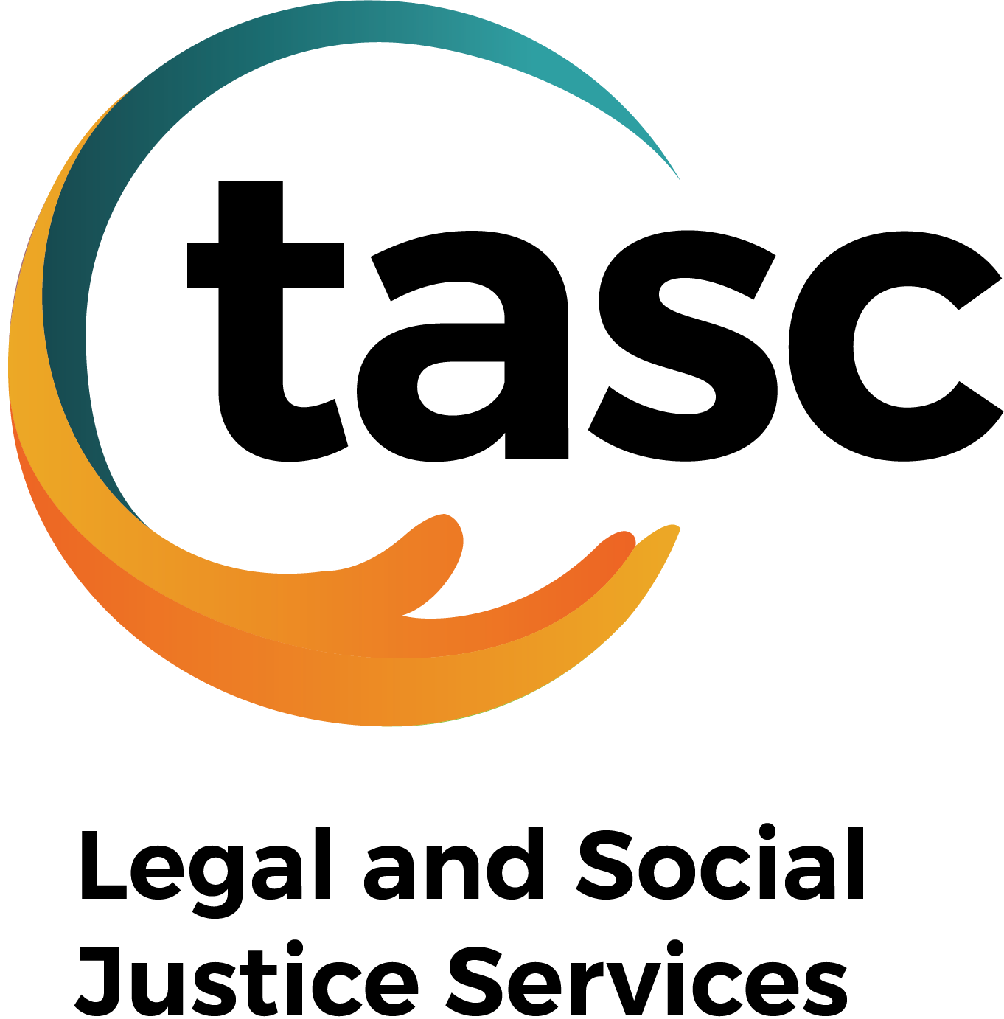
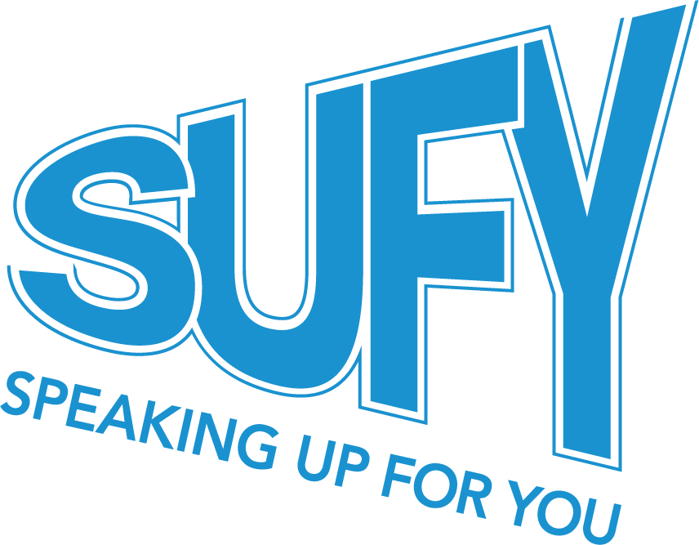



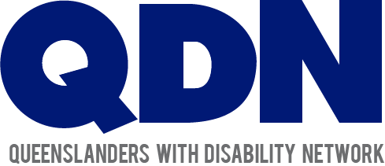


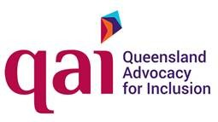


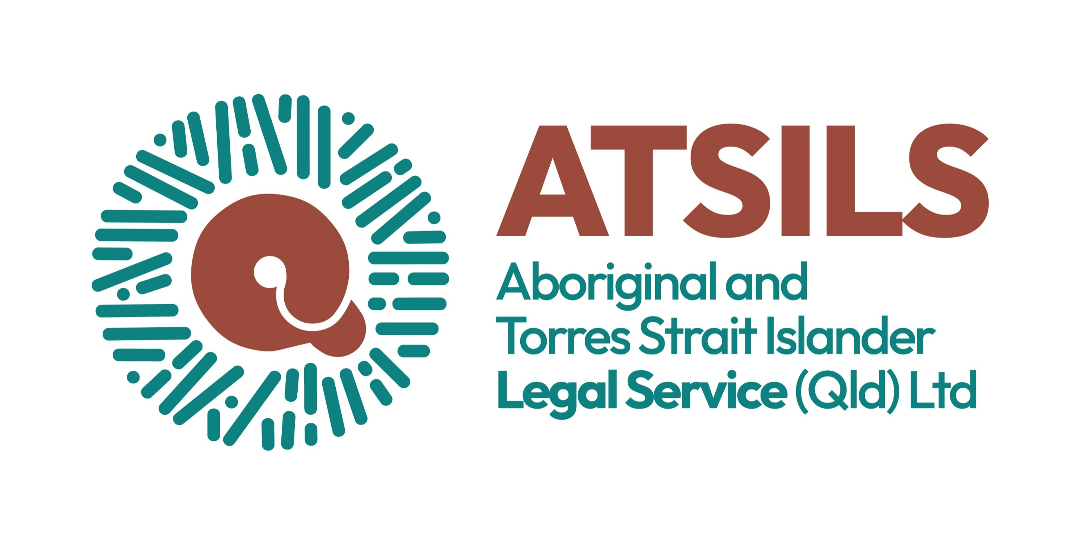

https://qidan.org.au/

