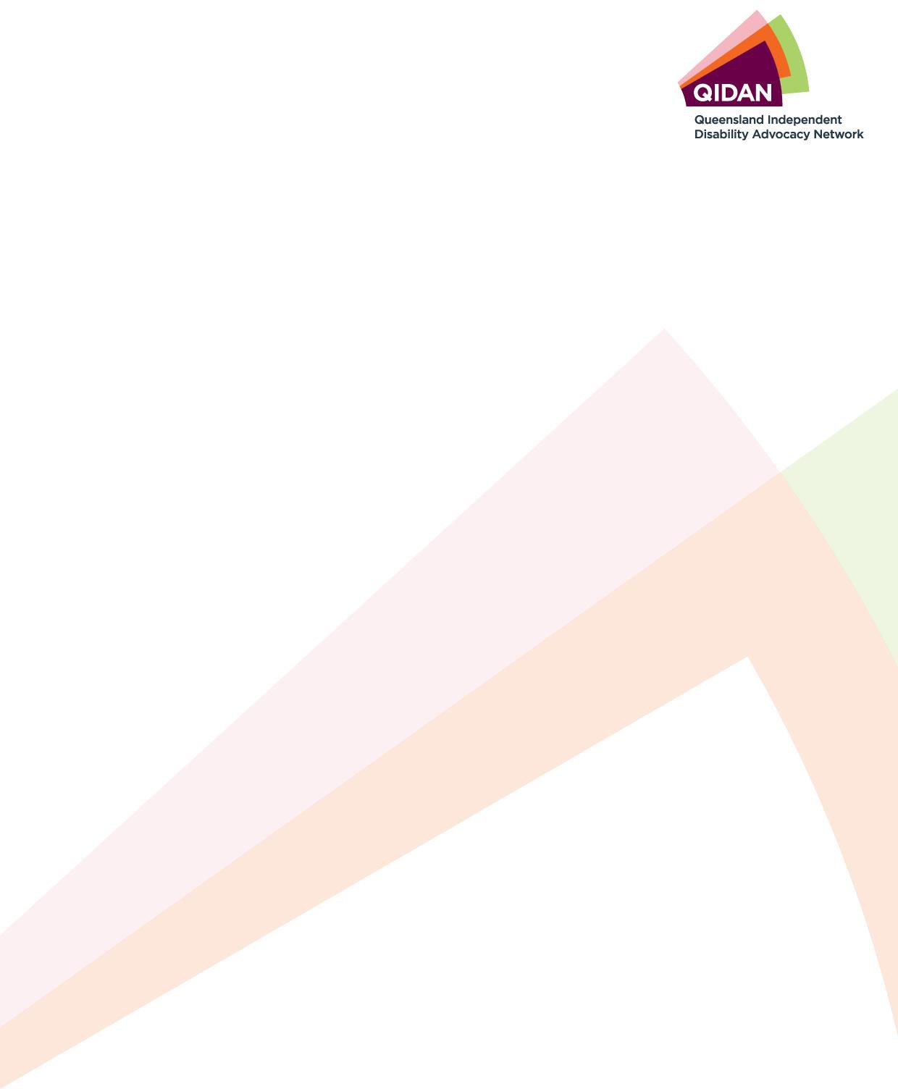

4 July 2025
The Hon. David Crisafulli MP

Premier of Queensland
Email: premier@ministerial.qld.gov.au
The Hon. John-Paul Langbroek MP Minister for Education and the Arts Email:education@ministerial.qld.gov.au

Dear Premier Crisafulli and Minister Langbroek
Regarding: Expansion of Special Schools and Co-Located Segregated Education in Queensland

I am writing on behalf of the Queensland Independent Disability Advocacy Network (QIDAN), which is a network of nine member organisations who are funded by the Queensland Government to provide independent disability advocacy to Queenslanders with disability. QIDAN has deep concerns about the Queensland Government's recent announcement of a significant expansion of special schools - a decision that entrenches segregation and stands in direct opposition to the rights of students with disability. QIDAN wish to note that new investment into special schools is in direct opposition to the findings and recommendations of the Disability Royal Commission.
QIDAN supports the Australian Coalition for Inclusive Education (ACIE) unequivocal opposition to the Queensland Government's announcement of new investment in segregated special schools, and we endorse the ACIE's "Let All Kids Learn Together" campaign and the attached letter that the ACIE has prepared.
Working together to achieve positive change for people with disability
Aged and Disability Advocacy Australia (ADAA) + AMPARO Advocacy+ Capricorn Citizen Advocacy (CCA) + Mackay Advocacy
+ People with a Disability (PWDA) + Queensland Advocacy for Inclusion (QAI) + Rights In Action (RIA) + Speaking Up For You (SUFY) + TASC National

Yours sincerely,
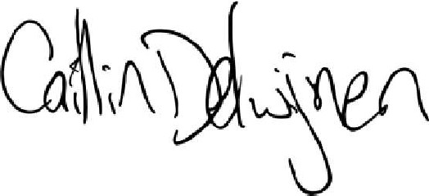
Caitlin de Cocq van Delwijnen
Principal Advocate, Queensland Advocacy for Inclusion
On behalf of the Queensland Independent Disability Advocacy Network (QIDAN)

QIDAN 2

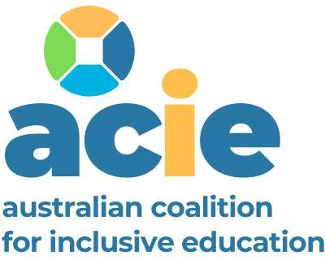
Date: 1 July 2025
The Hon. David Crisafulli MP
Premier of Queensland
Email: premier@ministerial.qld.gov.au
The Hon. John-Paul Langbroek MP Minister for Education and the Arts Email: education@ministerial.qld.gov.au
Dear Premier Crisafulli and Minister Langbroek
RE: Expansion of Special Schools and Co-Located Segregated Education in Queensland
We write on behalf of the organisations that comprise the Australian Coalition for Inclusive Education (ACIE), to express our unequivocal opposition to the Queensland Government's announcement of new investment in segregated special schools. This is not inclusive education. It is segregation - repackaged, rebranded, and in defiance of overwhelming evidence, community expectations, and the findings and recommendation of the Royal Commission into Violence, Abuse, Neglect and Exploitation of People With Disability (Disability Royal Commission).
ACIE is a national alliance of 25 organisations representing people with disability, families, educators and advocates across every Australian state and territory. Our collective membership exceeds 1.2 million members. We speak with one voice when we say that this decision represents a profound failure to uphold the rights, dignity and educational inclusion of children and young people with disability in Queensland.
Your government's announcement, promoted as "the largest special school investment in Queensland history", has sent shockwaves across the country. It is viewed nationally as a regressive, harmful move that is a betrayal of children, families, and the future of inclusive education in Australia.
Public money, permanent exclusion
There is no credible educational or human rights rationale for expanding segregated special schools in 2025. Separate settings do not improve educational outcomes. Co­ location does not foster belonging. "Parent choice" is a myth. Parents are not choosing special schools, they are conceding that mainstream schools cannot or will not support their child to be successful learners. Choice is meaningless when local schools are not resourced to include all students.
Redirecting public funding into segregated infrastructure entrenches systemic failure and guarantees that many children with disability will continue to be excluded from the very schools their siblings and peers attend. It sends a clear message: some children don't belong.
Misuse of Royal Commission findings
The Queensland Government's attempt to justify this policy based on Recommendation
7.15 of the Disability Royal Commission is misleading. That recommendation, put forward by Commissioners without disability, suggested co-location only as a transitional and conditional step-on the path to inclusion, not an end-state.
All the Royal Commissioners - with and without lived experience of disability - acknowledged that segregation causes harm and should not continue indefinitely, and all emphasised the need for progressive realisation of inclusive education. None endorsed the growth of segregation.
To invoke a divided recommendation as justification for a long-term expansion of separate schooling is not only disingenuous - it is an abuse of the Commission's findings, and it will not stand up to public, political or legal scrutiny.
Legal and reputational consequences
This decision risks breaching the Queensland Government's obligations under its own Human Rights Act, which guarantees the right to equality and the right of all children to education without discrimination.
It also places Queensland in jeopardy of a formal complaint under the Optional Protocol to the Convention on the Rights of Persons with Disabilities, given that State governments are not exempt from Australia's obligations under international law. The growth of segregation is not neutral-it is a legally actionable retrogression.
If your Government proceeds down this path, it will bear responsibility for reversing decades of progress. It will do so in full knowledge of the harm it causes and the opposition it will face - not only from people with disability, but from families, educators, researchers, and allies all across the country.
A growing national backlash
Since your announcement, we have been contacted by families, students and educators in Queensland and around the country - expressing outrage, distress, and fear that this model will spread nationally. The damage to Queensland's reputation as an inclusive state will only deepen as this decision comes under further national and media scrutiny.
A constructive alternative
It does not have to be this way. Inclusive education is not only possible-it is already working in schools today. But it requires investment in strengthening and implementing inclusive teaching practice system-wide, school leadership, accountability, and support. It requires courage-not containment.
We urge the Queensland Government to:
- halt all current plans to expand segregated special schools, including co-located models;
- recommit to investing in inclusive education within the general education system;
and
- engage with organisations in Queensland that have been at the forefront of inclusive reform for students with disability, including ACIE's Queensland members Community Resource Unit (CRU), Queensland Advocacy For Inclusion (QAI) and Queensland Collective for Inclusive Education (QCIE).
ACIE is currently finalising an updated National Roadmap for Inclusive Education, aligned with international best practice and the findings and recommendations of the Disability Royal Commission. We would welcome the opportunity to meet and share this work with you as a constructive contribution to Queensland's future education planning. However, we must express our serious concern that the current policy direction risks entrenching segregation and undoing hard-won progress toward inclusion. This is not a path any government should pursue in 2025, and we urge you to reconsider before lasting harm is done.

Yours sincerely
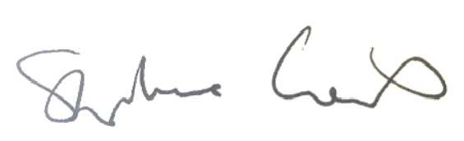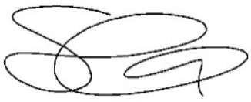

Stephanie Gotlib
Chairperson, ACIE - The Australian Coalition for Inclusive Education; Executive Director, All Means All
Ms Skye Kakoschke-Moore
Deputy Chairperson, ACIE - The Australian Coalition for Inclusive Education; CEO,CYDA

All Means All - The Australian Alliance for Inclusive Education (All Means All) -
National
Children and Young People with Disability Australia (CYDA) - National
Australian Disability Clearinghouse on Education and Training (ADCET) - National Australian Law Students Association - National
Autistic Self Advocacy Network of Australia and New Zealand (ASAN AUNZ) - National
Community Resource Unit (CRU) – QLD
Down Syndrome Australia – National
Enabled Youth Disability Network- National Family Advocacy - NSW
Grandparents Victoria/Kinship Carers Victoria (GPV/KCV) - VIC Imagine More - ACT
Inclusive Educators Australia - National JFA Purple Orange- SA
National Union of Students (NUS) – National
People With Disability Australia (PWDA) - National
Queensland Advocacy For Inclusion (QAI) – QLD
Queensland Collective for Inclusive Education (QCIE)- QLD
Sa4i - Student Alliance 4 Inclusion - National
Square Peg Round Whole - National (with dedicated NSW, WA and SA Chapters)
Star Victoria - VIC
Starting With Julius - National
Tasmanian Disability Education Reform Lobby – TAS
Women With Disabilities Australia (WWDA) – National
YDAS Youth Disability Advocacy Network-WA
YDAS Youth Disability Advocacy Service - VIC
