QIDAN Budget Submission
The Queensland Treasury

February 2026

Contents

Executive Summary 3
Our Impact 4
About the Queensland Independent Disability Advocacy Network 5
Demand for Advocacy in Queensland 6
Advocacy as Prevention 11
Disability Reform 11
Impact of Temporary Uplift Funding 12
Workforce sustainability and staff wellbeing 13
Connection with our Communities 15
The Future of Advocacy 16
Appendix 2 – Pathways Data Analysis 21
Appendix 3 – QIDAN Unmet Demand Data Analysis 24
Appendix 4 – Case Study 1 25
Appendix 5 – Case Study 2 26

Note on Language

Language is a powerful tool for building inclusion. We use person-first language by using the term ‘people with disability’ but recognise that many people with disability prefer identity first language (i.e. a disabled person). The term ‘people with lived experience’ is used for people with disability, as well as their family members, carers and kin.
For the purpose of submission, we use the term ‘client’ to describe a person with disability engaging with disability advocacy, and the terms ‘service’ and ‘matters’ interchangeably to describe when a person is provided with advocacy assistance to address an advocacy issue. We note that the sector typically does not like to use language like ‘client’ and ‘service’ to describe our work and the community that we work for. However, we are using this language for the ease of the reader.

Executive Summary
The Queensland Independent Disability Advocacy Network (QIDAN) is the statewide network for independent disability advocacy organisations supporting Queenslanders with disability. Through the Queensland Disability Advocacy Program (QDAP), QIDAN members collectively supported more than 1,700 people with disability over the financial year on over 3,400 complex advocacy matters involving issues like the NDIS, housing, domestic and family violence (DFV), justice, child protection and safeguarding systems. Demand for independent disability advocacy in Queensland is growing rapidly due to escalating social pressures, ongoing disability reform, and the absence of foundational supports. In 2024–25 alone, 48% of requests for advocacy could not be met due to the demand for advocacy exceeding our sector’s capacity.
Independent disability advocacy is a proven form of early intervention and prevention. The Disability Royal Commission (DRC) identified advocacy as critical to preventing abuse, neglect, violence and exploitation, and found that
the cost ratio of advocacy is at a minimum $2.21 of benefit for every $1 spent on [government] funding.
QIDAN is grateful for the Queensland Government’s temporary uplift funding to the QDAP. However, temporary funding does not allow for workforce stability, long-term planning or sustained service delivery. Without further investment, state funding will reduce to approximately $7 million, significantly undermining sector capacity at a time of rising demand.
QIDAN calls on the Queensland Government to:
- Guarantee no cuts to independent disability advocacy funding; and
- Increase ongoing investment in QDAP to $20 million per annum.

Our Impact
Services:

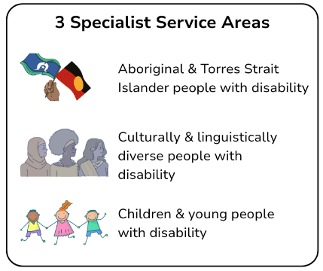
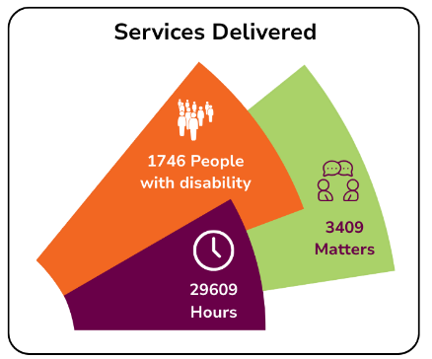
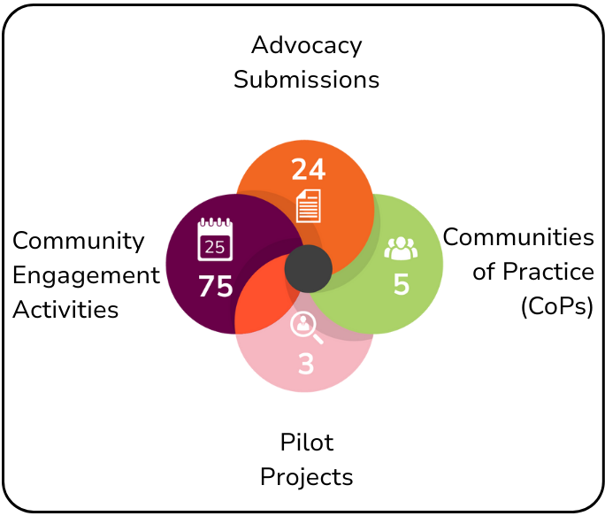

Demographics:
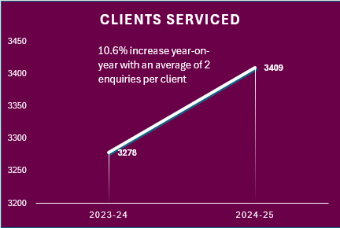
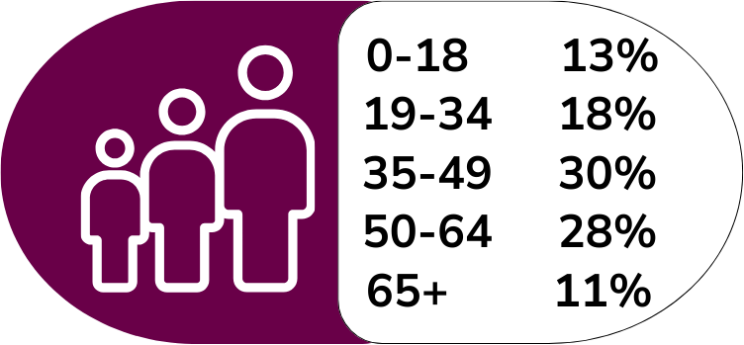

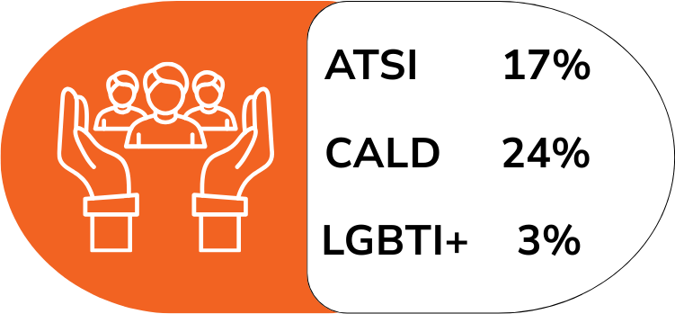

About the Queensland Independent Disability Advocacy Network
The Queensland Independent Disability Advocacy Network (QIDAN) is a statewide network of independent disability advocacy organisations supporting Queenslanders with disability across metropolitan, regional, rural and remote Queensland.
QIDAN’s member organisations include Aged and Disability Advocacy; AMPARO Advocacy Inc; Capricorn Citizen Advocacy; Mackay Advocacy Inc; People with Disability Australia; Queensland Advocacy for Inclusion; Rights in Action; Speaking Up For You; TASC; and Yarn2Action run by Aged and Disability Advocacy.
QIDAN has three core functions:
- Systemic advocacy: coordinated action to identify and address systemic issues experienced by people with disability
- Member support: facilitating collaboration, information sharing and sector capability
- Sector advocacy: promoting the value and impact of independent disability advocacy at local, state, and national levels
QIDAN members deliver general disability advocacy, specialised individual advocacy (including NDIS appeals), citizen advocacy and systemic advocacy. The Disability Pathways Hub provides information and referrals to people with disability, their families and supporters.
Independent disability advocacy works alongside people facing disadvantage to promote, protect, and defend human rights, interests, and wellbeing by:
- Supporting will and preference
- Remaining partisan, loyal and accountable to the person
- Acting professionally, culturally safe, and vigorously
- Avoiding conflicts of interest.
QIDAN’s perspectives and recommendations are grounded in the collective, lived experiences of advocates working directly with Queenslanders with disability.

Demand for Advocacy in Queensland
In 2024 to 2025, QIDAN members collectively recorded almost 30,000 hours delivering advocacy. We proudly advocated for 1,746 individuals with disability across 3,409 separate advocacy matters – matters that covered a range of complex issues and systems (see Appendix 1 for data analysis).
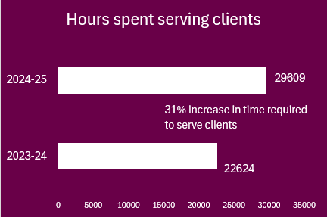
Over the financial year, we observed a distinct increase in the complexity of issues for certain groups of people with disability. The number of advocacy matters involving a person experiencing DFV increased by 27% compared to last year. LGBTQIASB+ clients required 25% more time on mainstream advocacy issues, and almost twice the amount of time for NDIS-related advocacy issues, compared to non-LGBTQIASB+ clients. Similarly, child protection matters delivered to clients from culturally and linguistically diverse (CALD) backgrounds took 2.1 time longer to resolve compared to non-CALD clients. Whilst the overall number of clients in general grew by 11% this financial year, the number of clients from identified groups increased significant higher, including:
- LGBTQIASB+ clients grew by 48%
- First Nations clients grew by 29%
- Clients from CALD backgrounds grew by 23%
Despite our efforts, QIDAN recorded 3,150 instances of unmet demand (see Appendix 3 for data analysis). Additionally, Disability Advocacy Pathways received 986 enquiries, 43% of which resulted in referrals outside of the advocacy sector due to a lack of sector capacity (see Appendix 2 for data analysis). The DRC Final Report investigated unmet demand within the disability advocacy sector, discovering that unmet demand is largely influenced by poor funding and resourcing constraints, concluding that “immediate action is needed to address the shortfall in funding”. This is true for QIDAN, and our ability to keep up with the demand for advocacy is greatly impacted by the lack of stable and adequate state funding. In fact, the uplift funding announced in the 2024 to 2025 Queensland Budget was only rolled out in October 2025, significantly stalling our ability to utilise the funding and expand the amount of independent advocacy we deliver.
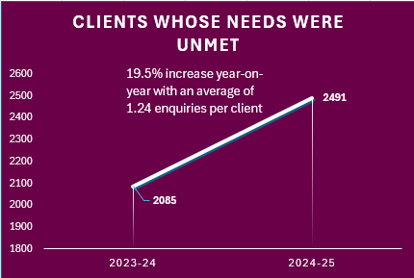
Unmet demand represents people with disability who are turned away from advocacy when they need it most, often meaning that the issue they are experiencing will escalate. For instance, our sector has been inundated with requests for help with NDIS-access at a rate that we cannot keep up with. Accessing the NDIS is an incredibly expensive and time-consuming process, and there is a very real chance that NDIS access may not be possible without an advocate’s support. This situation is made worse by the absence of Foundational Supports and an exhausted mainstream system, both increasing the risk for people having no disability-related supports at all. When fundamental needs are not met, quality of life can quickly deteriorate. Without support to maintain personal hygiene regularly, grocery shop, prepare meals, and access the community, a person with disability is at far greater risk of social isolation, financial disadvantage, maltreatment and deteriorating health and wellbeing.
Like unmet demand, it is also important to understand unmet need as it reflects issues (sometimes unknown issues) that are experienced by people with disability and are going unaddressed. It is crucial to acknowledge that First Nations people with disability and people from CALD backgrounds with disability experience unmet need at disproportionately high rates. In fact, the DRC noted that “First Nations, culturally and linguistically diverse and LGBTQIA+ people with disability experience [challenges] accessing culturally safe advocacy”. Some examples of groups of people with disability at greatest risk of unmet need identified by advocates include:
- Closed settings – people with disability forced to live in closed settings, including group homes, prisons, and forensic disability services. People in closed settings are at higher risk of maltreatment and discrimination and face significant barriers to accessing disability advocacy. The DRC Final Report identifies that advocacy is “a key factor in promoting the safety of people with disability in group homes” but also highlights that people with disability in these settings face significant barriers to access advocacy and their broader communities.
- “Social hospitalisation” – refers to people with disability who are admitted to hospital not because of an acute medical condition, but for social issues like lack of disability-related supports and/or homelessness. Social hospitalisation does not address the underlying issues that impact individuals with disability, and people in this situation often do not have the means to independently contact their local advocacy organisation. Furthermore, social hospitalisation causes significant strain on the public health system.
- Parents with cognitive disability and the child safety system – parents with cognitive disability are grossly overrepresented in all stages of the Child Safety system compared to non-cognitively disabled parents and are often targeted by the system due to discrimination and stereotyped beliefs about their parenting capacity. Often, parents with cognitive disability in this situation are not provided with information about their rights, including their rights to independent advocacy. This leads to countless families being fractured unnecessarily and significant strain on the child protection system.
- Youth justice – a significant portion of children and young people in the youth justice system have a disability. Whilst in the system, children and young people with disability do not have adequate access to disability-related supports and services, and their education and training journeys are often disjointed and not accessible due to ‘lockdowns’. Children and young people with disability often do not know what advocacy is and have significant barriers to independently reaching out to advocacy services.
At this stage, QIDAN does not have a consistent means to identify and measure unmet need. However, QIDAN member organisations have worked on several projects to better understand the advocacy needs within specific cohorts and regions, and to identify the barriers to accessing advocacy faced by these groups. The projects include Remote Locations Pilot Project, LGBTQIA+SB Pilot Project, and the Domestic and Family Violence Project (which is currently in progress).

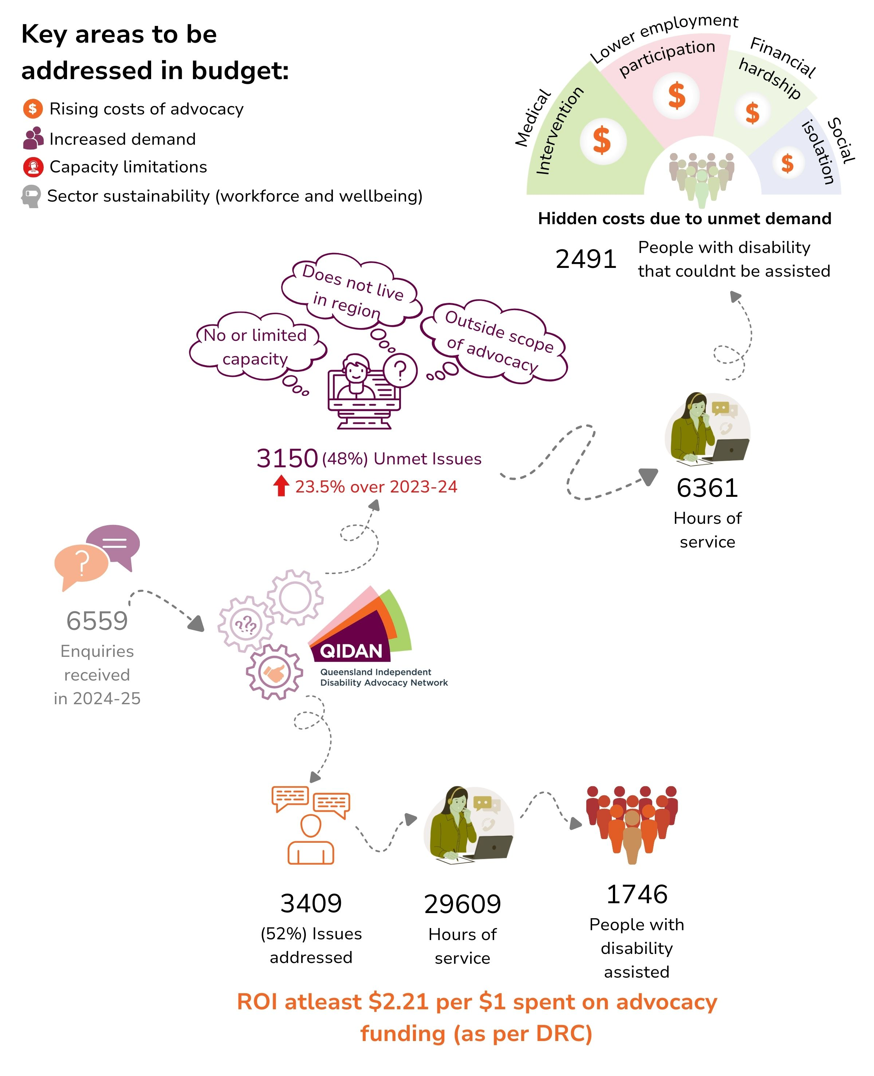

Advocacy as Prevention
Independent disability advocacy is an essential and cost-effective form of early intervention and prevention that can address and resolve issues before they escalate into something far more complex, dangerous, and costly. For instance, advocates across Queensland regularly assist people with disability to navigate a housing and tenancy issues, like resolving disputes with private rental providers, and advocating for access to social housing. These interventions can effectively reduce the risk of homelessness (see Appendix 5 for case study). Not only does advocacy play a vital role in improving safety, inclusion and equity for Queenslanders with disability and our communities, improving access to advocacy reduces downstream costs for housing, health, justice and crises services. The work of advocates also positively impacts systems at large, and can set precedents that improve complaints handling, inform safeguarding mechanisms, and service provision generally. Disability Advocacy is a part of the disability ecosystem. For the ecosystem to work effectively, the State Government needs to invest in Queenslanders with disability as a whole. This includes funding for things like inclusive education and employment, community-based programs, Foundational Supports, and peer networks and self-advocacy groups.

Disability Reform
Ongoing disability reform continues to increase demand for independent advocacy. The NDIS Review has drastically altered the ways that many people with disability access disability-related supports, making it significantly harder for many people to get the essential support they need (see Appendix 4 for case study). This and more has amplified the need for advocacy, and advocates have played a key role in supporting individuals to address these problems and to navigate the reform by:
- Contributing to consultations, like the design of Targeted Foundational Supports and the implementation of DRC recommendations.
- Responding to reviews of policy, legislation, and disability-related plans, highlighting the stories and wishes of people with disability and making tangible and proactive recommendations.
- Analysing and breaking-down information about reforms and relaying it back to our communities, such as through social media posts and blog posts.

Impact of Temporary Uplift Funding
In the 2024 to 2025 Queensland Budget, the Queensland Government provided a $5 million temporary uplift to Queensland Disability Advocacy Program (QDAP) funding, increasing total state investment to $12 million. The Queensland budget papers confirmed that the uplift funding was in response to the DRC’s Final Report, which repeatedly recognised the value of independent disability advocacy in preventing abuse, neglect, violence and exploitation of people with disability. The Queensland budget also links the funding to the NDIS Review, which acknowledged that disability advocacy “plays a critical role in promoting, protecting and defending the human rights of people with disability”, further recommending that all levels of government should jointly invest in access to individual disability advocacy services. Over the financial year, the uplift funding has provided the advocacy sector with many opportunities to invest in our workforce, improve operations and build relationships with our communities. However, due to it being temporary funding, QIDAN cannot plan to continue this work long-term. What is more, without further investment, QIDAN members will be left with only $7 million in state funding to meet the growing demand for advocacy and cover operational, staffing, travel, outreach, community education and community engagement costs.

Workforce sustainability and staff wellbeing
Sector sustainability is essential – a strong workforce enables our teams to better meet the needs of our communities, and well-functioning operations allows us the room to build relationships with our communities. However, for several years, the funding provided to the Queensland advocacy sector has been incredibly limited, impacting our sustainability and restricting our ability to meet the need for advocacy in our communities. We rely on the current uplifted funding, and any cuts to the Queensland funding will impact our sector’s sustainability and drastically reduce our workforce and capacity.
QIDAN’s focus on investing in the sustainability of our sector comes at a critical time, and in the most recent nation-wide Advocacy Sector Workforce Survey, the National Centre for Disability Advocacy (NCDA) found that:
“one-third of the sector reported that their work impacts their health and wellbeing on a weekly basis”.
The top causes of stress and overwhelm at work reported in the survey were related to managing client expectations, not having enough time to complete all tasks, managing unmet demand, and vicarious trauma. These pressures and more can be recurring and cumulative, leading to declining job satisfaction, burnout and, in some cases, resignation. Temporary uplift funding has supported workforce stabilisation and operational sustainability by opening opportunities for:

- Recruiting new staff members to increase the si

- ze and capacity of teams to better meet the demand for advocacy.

- Covering and investing in organisational overheads, such as funding new intake and administrative staff (one organisation did not previously have the funding for an intake officer role, and the intake work was handled by advocates. The uplift funding allowed the organisation to hire a new intake officer, radically improving the intake process and organisational capacity).
- Promoting, and creating new roles for existing staff to meet unique organisational needs and to recognise and reward continued hard work.
- Investing in training and professional development activities aimed at increasing knowledge and skills and building resilience and protective factors.
- Developing induction resources for new workers. Streamlining induction reduces the impact of training and mentoring that is usually placed on existing staff.
- Updating technology, including investing in new databases, purchasing new equipment like computers, and updating websites (technology is often the last place that is invested in, yet updated equipment and systems can significantly improve access to advocacy for people with disability as well as advocate’s day-to-day work).
These investments have already resulted in better advocacy – improving capacity, skills, wellbeing, and service quality. For example, Mackay Advocacy has been actively and consistently engaging with the local Aboriginal Yuwi peoples, Torres Strait Islander peoples, and South Sea Islander peoples, and the Mackay Advocacy team regularly engages in cultural training with emerging Elders. This type of investment leads to advocacy practice being more culturally inclusive and responsive. In addition, many of the organisations who used the uplift funding to hire new staff members have reported a noticeable increase in the amount of advocacy provided, including Capricorn Citizens Advocacy who almost doubled the amount of advocacy reported in the 2024 to 2025 financial year compared to the previous year. Without funding certainty, organisations face the risk of staff attrition, loss of expertise and reduced regional coverage.

Connection with our Communities
Forming and maintaining meaningful connections with our communities is central to effective disability advocacy. QIDAN members work extensively in regional, rural and remote communities, with First Nations people with disability, people from CALD backgrounds with disability, and children and young people with disability. We must consistently have a presence in our regions to develop trusted relationships with our communities. Of course, this takes an investment of time and resources – all of which comes with a cost. The temporary uplift funding has allowed many QIDAN member organisations to increase outreach, strengthen referral pathways, and improve access to advocacy in communities that were previously difficult to reach due to geographic and resource constraints. Cuts to QIDAN’s current funding would significantly undermine these relationships, reducing access to advocacy for people with disability who already experience heightened risk of abuse, neglect and exclusion.

Funding Ask: Securing Advocacy for Queensland
Over the past two years, the demand for independent advocacy has grown, and we expect that it will continue to grow due to factors like population growth, Queensland’s mounting social issues, limited support options, and ongoing disability reform. Advocates play a pivotal role in both supporting people to navigate these issues, and to address these issues on a systemic level. The only way for our sector to keep up with the growing demand for advocacy is to grow our sector, which can only be made possible through increased investment.

QIDAN calls on the Queensland Government to:
- Guarantee no cuts to independent disability advocacy funding
Maintaining current funding levels is essential to avoid immediate reductions in service capacity, workforce loss and increased unmet demand.
- Increase ongoing investment in QDAP $20 million per annum
An increase to $20 million annually would:
- Stabilise the advocacy workforce and retain experienced staff
- Reduce unmet demand and waitlists across Queensland
- Sustain outreach and face-to-face services in regional, rural and remote areas
- Strengthen safeguarding, prevention and early intervention outcomes
- Deliver long-term cost savings through reduced reliance on crisis and tertiary services.

The Future of Advocacy
There are approximately 1.2 million people with disability living in Queensland, many of whom will experience an array of complex issues and barriers and would benefit from the support of an individual advocate in their lifetime. Consequently, the need for advocacy and the demand for our services heavily outweighs our capacity under current funding arrangements. Independent disability advocacy is an essential safeguard that keeps Queenslanders with disability safe, supported and included.
An investment in independent disability advocacy is an investment in prevention, systems efficiency and community wellbeing. QIDAN urges the Queensland Government to provide stable, adequate and ongoing funding to ensure advocacy remains accessible to those who need it most.

Appendix 1 – QDAP Data Analysis
The data referred in this data analysis relates to advocacy matters that are delivered under the Queensland Disability Advocacy Program (QDAP) during the 2024-2025 financial year. Over the financial year, advocates across the state spent 29,609 collective hours advocating for Queenslanders with disability. Advocates delivered 3,409 advocacy matters to 1,746 individual people with disability. This means, on average, each individual advocacy client received advocacy to address two separate issues.
Primary issues
Over the financial year, 60% of advocacy matters addressed mainstream (or non-NDIS) issues, and the remaining 40% addressed NDIS-related issues. Access to the NDIS was the most common type of issue reported, representing 22% of all advocacy matters. Housing and tenancy matters were the second most common type of issue (20.1%) which is again double the rate from the previous financial year.
There are several other mainstream (non-NDIS) advocacy issues that are also on the rise compared to the previous financial year, including child protection related matters, matters addressing abuse/neglect/violence, and health/mental health related matters.

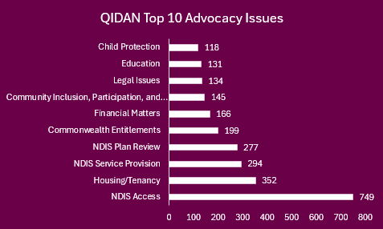

Primary disability type
QIDAN records a primary disability for each advocacy client, but it is important to note that many advocacy clients live with multiple disabilities, health and mental health conditions. The most common primary disability was psychosocial disability (23.2%), physical disability (20.3%), and autism (16.5%). The types of disability that someone has can influence the barriers, discrimination and abuse that they face. For instance, our data shows that people with psychosocial disability were far less likely to have NDIS access compared to other clients. With the overdue rollout of Foundational Supports, people with psychosocial disability often do not have any support, and access to treatment.

Time spent
QIDAN spent a total of 29,609 hours over the financial year delivering advocacy matters. It should be noted that the time spent delivering advocacy has been significantly under-reported by advocacy organisations across the state. It is clear from the data that certain types of advocacy issues had significantly higher average hours per advocacy matter recorded. This is also the case for advocacy provided to people with certain types of primary disability, advocacy matters involving a person with sensory speech disorders took on average 28 hours per matter.

Average time required to resolve the most time intensive
issues raised by client group (hours)
 | Overall Average | ATSI | CALD | LGBTQIA+
Mental health | 21.3 | 33.3 | 3 | --
Child protection | 13.4 | 8.9 | 28.0 | 35.5
Legal issues | 12.7 | 18.6 | 6.4 | --
Domestic & family violence | 11.8 | 13.5 | -- | 10.3
NDIS plan reviews | 7.7 | 6.5 | 6.1 | 32.9
Note: the overall average recorded: 8.7 hrs per advocacy matter.

Intersectionality
People with disability who engage with advocacy often belong to many different intersecting identities and backgrounds, including cultural, ethnic, gender, sexuality, and socio-economic backgrounds. During the financial year, 17.4% of advocacy matters were provided to a First Nations person with disability, and the most common advocacy issues that First Nations clients had over the year related to the NDIS, including access to the NDIS (18%). Additionally, First Nations clients with mental health, legal and DFV related advocacy matters took 1.5 times longer to resolve compared to non-First Nations clients.
Whilst 13.5% of clients who received advocacy were from a CALD background, matters involving a person from a CALD background accounted for 23.82% of advocacy issues. What is more, each client from a CALD background had on average 3.4 advocacy matters each. 13.1% of advocacy matters involved a person who used interpreters for spoken languages other than English. Like with First Nations clients, the most commonly reported advocacy issue that CALD clients had over the year were issues with access to the NDIS (14.5%), closely followed by housing and tenancy issues (14.1%).
Only 3% of advocacy matters were provided to LGBTQIASB+ people with disability according to QIDAN data. However, this is likely underreported. Of all advocacy matters provided to LGBTQIASB+ clients, the most common advocacy matters addressed during the financial year were NDIS access (18.8%), housing and tenancy issues (17.8%).
Over the financial year, 49.8% of advocacy matters were provided to men, and 48.5% were provided to women. There were 14 matters provided to intersex persons, 9 matters provided to non-binary persons, and 1 matter was provided to a transgender person.

At-Risk Communities
Over the financial year, over a quarter (26%) of advocacy matters were provided to a person experiencing, or at-risk of experiencing, homelessness. Access to safe and stable housing is a fundamental need, and homelessness can lead to irreversible harm to a person’s health and wellbeing and places them at exacerbated risk of abuse and neglect.
17.1% of advocacy matters involved a person experiencing DFV. Within this group of people, 43.1% were either experiencing, or were at-risk of experiencing, homelessness, and the majority had cognitive disability. Concerningly, QIDAN has seen a steady and consistent rise in DFV within our advocacy.
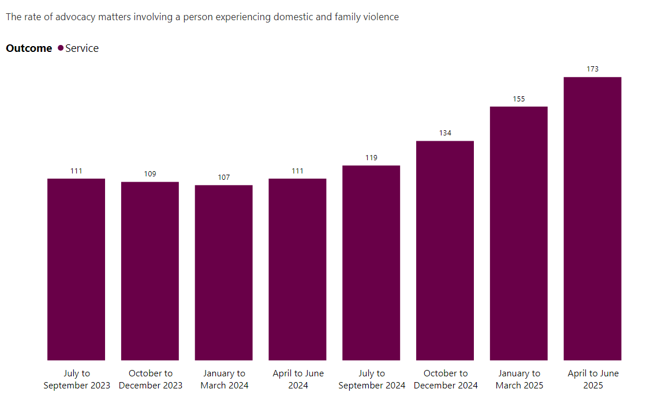
44.6% of advocacy matters were provided to a person who did not have access to the NDIS. In most situations, having the NDIS is key to accessing disability-related services and supports. One-quarter of the advocacy matters for people who do not have NDIS access were also people from a CALD background, a great deal of whom had acquired brain injuries. More information about the work of QIDAN members over the finical year can be found in our 2024-2025 annual report.

Appendix 2 – Pathways Data Analysis
The data referred in this data analysis relates to Disability Advocacy Pathways (Pathways) under the Queensland Disability Advocacy Program (QDAP) during the 2024-2025 financial year. Pathways is a service that assists Queenslanders with disability, their family, friends and carers to find advocacy services to suit their needs and locations.

Referrals
Over the financial year, Pathways received 987 enquiries. The aim of Pathways is to prevent the constant “referral-round-about” often experienced by people with disability seeking advocacy and other supports. Because of the sector’s chronic lack of capacity, Pathways often make referrals outside of advocacy to other services, like neighbourhood centres, community services, community legal centres, and health services. Pathways Officers made 859 simple referrals, 46.6% of which were made to advocacy organisations across Queensland. Pathways also made 54 facilitated referrals, only 39% of which were made to advocacy organisations. 7.4% of enquiries made to Pathways resulted in no referrals being made. In situations where no referral is possible, Pathways Officers provide valuable information and resources with the intention of promoting self-advocacy. It should be noted that many of these enquiries received by Pathways meet advocacy criteria.

Primary issues
The most common type of primary issues that Pathways reported over the financial year were administrative enquiries including requests for support to make complaints, engage in appeals process, attend tribunals (13.5%); NDIS access support (12.6%); and housing and tenancy related issues (10.3%).
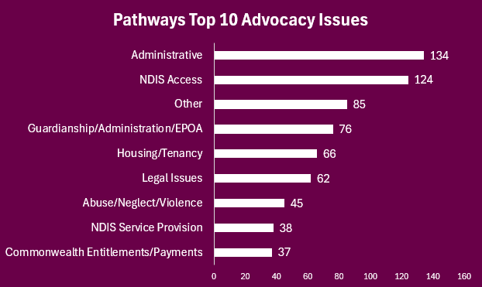

Disability and Intersectionality
The most common types of primary disability recorded by Pathways were other disability type (35%); psychosocial disability (15.4%); physical disability (12%); and Autism (11.5%).
Most enquiries received by Pathways involve a person with disability whose lives are shaped by intersectionality, and:
- 5.8% of enquiries involved an First Nations person.
- 2.2% of enquiries involved a person from a CALD background.
- 20.7% of enquiries involved a person who was experiencing DFV
- 51.8% of enquiries involved a person experiencing financial disadvantage.
- 26.2% of enquiries involved a person who was experiencing, or was at risk of experiencing, homelessness.
It is important to note that the rate of reports of risk factors, including DFV, homelessness, and financial disadvantage, grew significantly in the 2024 to 2025 financial year compared to the previous financial year. Additionally, the low rate of enquiries for First Nations people with disability and people from CALD backgrounds with disability highlights the additional barriers that some people experience when reaching out and seeking help from services they are not familiar with, and establishing trusting relationships with First Nations communities and CALD communities takes time and resources.
Community engagement
Over the financial year, Pathways connected with more than 65 community organisations, across ten local government areas, including DFV services and legal services. Pathway’s community engagement work raised awareness on the role of disability advocacy and strengthened referral pathways for seeking advocacy. Over 9% of new enquiries to Pathways were directly related to the work that the community engagement advocate undertook.

Ex-Tropical Cyclone Alfred
In times of natural disasters, Pathways has the capacity to activate extended hours and expand its scope to meet increased demand with greater flexibility, and in early 2025 in anticipation of Ex-Tropical Cyclone Alfred, the Department requested Pathways to increase operating hours before, during and after the natural disaster. More about the support provided during this time can be found in the Report – Reflections from Pathways’ response to Cyclone Alfred.
During this time, Pathways received many complex enquiries, with at least 1 in 3 people experiencing financial disadvantage and risk of homelessness. Enquiries were longer than a typical Pathways enquiry, taking on average 1.2 hours, and the longest single enquiry lasting 7 hours. Most people were referred to government agencies for further assistance due to the kind of escalation required and a lack of non-government services that were known, appropriate and available.

Appendix 3 – QIDAN Unmet Demand Data Analysis
The data referred in this data analysis relates to unmet demand recorded by QDAP during the 2024-2025 financial year. QIDAN reported 3,150 occurrences of unmet demand, which is a 23.5% increase in unmet demand from the previous financial year. 2,491 individuals with disability experienced unmet demand (19.5% increase in clients with unmet demand), which means there were people who couldn’t access advocacy on several separate occasions. For reference, QIDAN considers enquiries that have been referred on and enquiries that are kept on a waitlist as unmet demand, as the advocacy need could not be met at that point in time. In total, there were 6,361 hours recorded on unmet demand, which means that every unmet enquiry took on average 2 hours.

Demographic information
The most common types of primary disability reported in QIDAN’s unmet demand data were physical disability (28.5%) and psychosocial disability (20.5%). 26.1% of unmet demand involved a person who did not have NDIS access at the time of their enquiry, which could mean that these individuals had very little support whilst they were trying to navigate their issue.

Issue type
The most common types of issues reported in QIDAN’s unmet demand data were enquiries for NDIS access (15.5%), support with legal issues (11.9%), and NDIS plan reviews (10%). Though almost all the different types of issues recorded as unmet demand took on average 2 hours each to address, one type of issue appears to be considerably more complex. Enquiries related to child protection accounted for only 1.5% of unmet demand but took on average 5 hours each to refer or provide information. 69% of unmet child safety enquiries were made by a person over the age of 18, likely from parents with disability requiring support to navigate the child safety system. Most of these adults with child protection related issues had cognitive disability.

Appendix 4 – Case Study 1
Carol’s* experience – the critical role of local, face-to-face advocacy
Advocates from Mackay Advocacy Incorporated (MAI) were contacted by Carol and her support worker seeking assistance to change NDIS Support Coordinators after her NDIS funding was exhausted. Carol lived in a regional town, and because advocates were undertaking outreach in the region that same week, they were able to meet with her face to face.
During the in-person visit, advocates identified a range of serious and compounding risks that had not been evident through phone contact alone. Carol was bedbound and living alone in unsafe conditions, with inadequate supports following a fall that resulted in a broken ankle and hip. Her NDIS funding had been exhausted, and remaining supports were insufficient to meet her needs. Advocates also identified domestic and financial abuse, with Carol’s former partner living in the home, controlling her finances and belongings, despite Carol reporting ownership of the property prior to the relationship. The home itself was unsafe and inaccessible, with a broken toilet, mould, water leaks, broken doors without locks and no air-conditioning. Further, although Carol had an enduring power of attorney in place for financial matters, the appointed family members were unwilling to act, leaving her without access to her own finances.
With Carol’s consent, advocates escalated an urgent NDIS review and engaged a Complex Case Manager, supported the appointment of a new Support Coordinator, and secured medium-term accommodation in a standalone Specialist Disability Accommodation with 24/7 supports. Advocates also supported Carol to remove the former partner as Centrelink nominee, initiated a fraud report regarding misuse of her pension and carer payments, and connected her with specialist services including legal advice, counselling, and women’s support services.
*Name changed for confidentiality purposes

Appendix 5 – Case Study 2
Marian’s* experience – advocacy’s role in navigating serious social issues
Marian* is a woman based in Brisbane who lives with disability and history of complex trauma. When Marian first contacted Speaking Up For You (SUFY), she was experiencing homelessness. An advocate from SUFY helped Marian to engage with the Department of Housing and specialist housing services, and Marian was quickly offered short-term accommodation in a motel. Unfortunately, the motel accommodation was unsafe for Marian and was a one-hour drive away from her health services. During the motel placement, Marian became very ill and did not have adequate access to her treating team, eventually resulting in a hospital admission. At this time, the advocate working with Marian noticed that Marian was afraid of returning to the motel upon hospital discharge. The advocate also realised that shared accommodation, such as boarding houses, were not appropriate housing options for Marian due to her history of trauma. Once discharge from the hospital, Marian had no other choice but to live in her car.
The advocate visited Marian regularly, observing that she had great difficultly communicating with housing services. In particular, the advocate noticed that the specialist housing services and the local Housing Service Centre lacked disability and trauma awareness. This lack of awareness led to misunderstandings and harmful interactions, which impacted Marian’s wellbeing and trust in the services. Furthermore, the stress of homelessness and the burdens of health-related costs significantly impacted Marian’s health, which progressively worsened. On Marian’s behalf, the SUFY advocate navigated the housing services, making numerous calls, emails and letters to the services to inform them of the disability-related barriers, disadvantage, and marginalisation that Marian experienced in the housing system. The advocate highlighted Marian’s need for her own accommodation and stressed the impact that homelessness was having on Marian’s health and wellbeing. After several months of tireless advocacy, Marian was approved for a Community Housing property, and she now lives in her own home.
*Name changed for confidentiality purposes

Taylor Fry and the Centre for International Economics (2023). Increased funding to meet demand for disability advocacy services. Retrieved from https://disability.royalcommission.gov.au/system/files/2023-09/Increased%20funding%20to%20meet%20demand%20for%20disability%20advocacy.pdf
Queensland Independent Disability Advocacy Network. QIDAN. https://qidan.org.au/
Disability Advocacy Pathways. Disability Advocacy Pathways. https://disabilitypathways.org.au/.
Royal Commission into Violence, Abuse, Neglect and Exploitation of People with Disability. (2023). Enabling autonomy and access. https://disability.royalcommission.gov.au/system/files/2023-09/Final%20Report%20-%20Volume%206%2C%20Enabling%20autonomy%20and%20access.pdf page 289
Commonwealth of Australia. Royal Commission into Violence, Abuse, Neglect and Exploitation of People with Disability. Enabling autonomy and access. Final Report Vol. 6 (2023, P 255).
Royal Commission into Violence, Neglect and Exploitation of People with Disability. (2023). Enabling autonomy and access. https://disability.royalcommission.gov.au/system/files/2023-09/Final%20Report%20-%20Volume%206%2C%20Enabling%20autonomy%20and%20access.pdf
Royal Commission into Violence, Abuse, Neglect and Exploitation and People with Disability. (2023). Parents with disability and their experiences of child protection systems. https://disability.royalcommission.gov.au/system/files/2023-07/Research%20Report%20-%20Parents%20with%20disability%20and%20their%20experiences%20of%20child%20protection%20systems.pdf
Queensland Family & Child Commission. (2024). Addressing the root causes. www.qfcc.qld.gov.au/sites/default/files/2024-11/2024085%20Youth%20Justice%20-%20Addressing%20the%20Root%20Causes%20-%20Snap%20Shot.pdf
Queensland Independent Disability Advocacy Network. (2025). Remote locations pilot. https://disabilitypathways.org.au/wp-content/uploads/2025/04/Remote-Locations-Pilot.pdf
Queensland Advocacy for Inclusion. (2025). LGBTQIA+SB pilot project report. https://qai.org.au/wp-content/uploads/2025/09/QAI-LGBTQIASB-Pilot-Project-Report.pdf
Queensland Government. (2025). Queensland Budget 2024-25: Service Delivery Statements. https://www.treasury.qld.gov.au/files/Budget_2024-25_SDS_Child_Safety_Seniors_and_Disability_Services.pdf
Ibid
National Disability Insurance Scheme (2023). NDIS Review: working together to deliver the NDIS. Pg. 57. Retrieved from https://www.ndisreview.gov.au/resources/reports/working-together-deliver-ndis pg. 57
Ibid. pg. 61
National Centre for Disability Advocacy. (2025). Advocacy sector workforce survey: 2024 results report. https://ncda.org.au/wp-content/uploads/2025/07/Advocacy-Workforce-Survey-Results-2025-final-1.0.pdf
National Centre for Disability Advocacy. (2025). Advocacy sector workforce survey: 2024 results report. https://ncda.org.au/wp-content/uploads/2025/07/Advocacy-Workforce-Survey-Results-2025-final-1.0.pdf
Queensland Independent Disability Advocacy Network. (2026). Submission to IDAP Consultation: https://qidan.org.au/submissions/qidan-submission-to-idap-consultation/.
Queensland Government. (2025). Disability statistics. https://www.qld.gov.au/disability/community/disability-statistics

