2 October 2025

Standing Committee on Health, Aged Care and Disability
PO Box 6021
Parliament House
CANBERRA
Canberra ACT 2600
Email: Health.Reps@aph.gov.au

Thriving Kids Inquiry
We welcome the Australian Government’s interest in ensuring children with disability are adequately supported and we welcome the opportunity to provide a submission to the Thriving Kids Inquiry. We greet the members of the Standing Committee on Health, Aged Care and Disability, and we acknowledge their unique and individual experiences as members of our community, parents, people with disability, medical professionals working towards making life better for the children and their families, both in the present, and for our children in the future.
Coordinated by Queensland Advocacy for Inclusion (QAI), QIDAN is a group of organisations funded under the Queensland Disability Advocacy Program (QDAP) to provide individual advocacy assistance to Queenslanders living with disability. The members of QIDAN offer various independent disability advocacy programs across Queensland, including the Young People’s Program which is specialist advocacy program that assists people with disability under the age of 18. Some of our members are also funded through the National Disability Advocacy Program (NDAP) and the NDIS Appeals Advocacy Program.
During the 2024-25 financial year, QIDAN assisted 536 children and young people in Queensland. Our data further reveals that:
- 17.5% were non-NDIS participants
- 15% were First Nations children, and
- 20% were children from culturally and linguistically diverse backgrounds.
- Autism was the third most common primary disability reported. Most children and young people with autism accessed advocacy for help with education related issues.
We all want every child to feel supported and included in our communities. In many instances, mainstream services and the NDIS have excluded children with disability, and the Thriving Kids program offers an opportunity to change that reality. Shared decision-making, with children and families leading the process, will result in better outcomes for every child and their families, as they feel included in the design of their lives and futures.
Consultation process
In June 2024, QIDAN provided advice to the Queensland Government on the development of a disability Targeted Foundational Supports Service System (TFSSS). In December 2024, QIDAN provided a submission in response to the DSS’ General Foundational Supports consultation. We believe the recommendations provided in both reports (TFSSS final report and General Foundational supports submission) are directly relevant to the development and implementation of the Thriving Kids program, and we ask the Committee to consider our recommendations for the purpose of this Inquiry.
We understand the Thriving Kids program is informed by the findings of the national consultation of Foundational Supports held at the end of last year. We are pleased to know the design of this program will be informed by experts, the findings of the Independent Review of the NDIS as well as the Thriving Kids Advisory Group. It is important the Committee builds on findings and recommendations that resulted from people’s stories, like Action 1.12 of the Independent Review of the NDIS. We suggest the Committee carefully considers the Supporting Analysis of Action 1.12, which provides further details and suggestions of how supports can meet the needs of children and families. More importantly, families and children should be leading the Thriving Kids consultation and design. Volume 5 of the DRC Final Report recommended including people with disability in leadership positions to advance equality, inclusion and the rights of people with disability.
A great way to connect with children with disability and their families is in their natural settings – for example, neighbourhood centres, schools, local libraries and shopping centres. Children and families who have no access to supports are the most isolated and are the most in need of supports, they are also the best problem solvers because they solve problems and overcome challenges every day.
Opinion and proposals
In the beginning stages of the Thriving Kids program and based on Minister Butler’s announcement on 20 August 2025 and in addressing the Inquiry’s Terms of Reference, we would like to share with you our recommendations of what the program could look like based on our expertise and collective experience supporting kids with disability and their families.
Scaling and building on existing mainstream and community services
Ensure every school has a dedicated team of therapists to support children and families within the natural school setting, without removing the child from their classroom. This supports inclusion and reduces feelings of isolation and/or of inadequacy, by both children and parents. Social workers and peer programs could be delivered in existing community and neighbourhood centres as well libraries, as they already offer a place of inclusion and social interaction.
Evidence-based support and resources
In examining evidence-based information and resources, the Committee should focus on families and children with lived experience – they are the experts in their own lives, and this form of expertise is vital to good decision making. Whilst research is of extreme value, we recommend the Committee uses evidence that includes personal stories and that is produced, where possible, by people with disability. The Thriving Kids program should respond to intersectionality as it changes children and families’ experiences in all aspects of life, it doesn’t just add to it.
Peer support programs as well as age-appropriate respite programs
Families and children require supports that are embedded in disability pride and which allow families choice and control over providers and support delivery, with flexible supports before burnout. Playgroups should include both children with and without disability, incorporating age-appropriate disability awareness and encouraging inclusion from early age.
Family and carers support
Establish or build on existing community based ‘hubs’ for children and families providing therapies, community support, skill development, and essential resources like food and toiletries. This needs to be accessible to children within and outside the school system and include proactive check-ins for families during overwhelming periods. Workforce support and training should include mandatory training on human rights and disability awareness, but beyond that, it should include training provided by parents who have become experts in supporting their children.
Navigating different services – within and outside the NDIS
As the Thriving Kids program gradually rolls out, we understand navigation supports will be an essential support for families and children accessing supports outside the NDIS and other services. Advocates perform several functions compatible with a navigation role including provision of information, advice or referral and help people navigate complex systems, therefore they are well placed to support people during the transition as the Thriving Kids program is implemented.
Conclusion
In closing our submission, we would like to highlight some questions around the proposed timing and resourcing of Thriving Kids, as raised by the Disability Representative Organisations in their ‘Nothing about us, without us’ open letter. While we welcome additional investment in supports for children with disability, it is crucial that any investment is carefully planned and that interactions with other systems are considered (like between the NDIS and education system), with people with disability leading the work. We reiterate the voices of children and families must lead the design of the Thriving Kids program.
We look forward to further discussing the establishment of the Thriving Kids program and its potential to achieve the best outcomes for children under 9 and their families. We hope you will consider our recommendations already made to both the Queensland and the Australian governments. I can be contacted via email (caitlin@qai.org.au) or on 07 3844 4200.

Yours sincerely
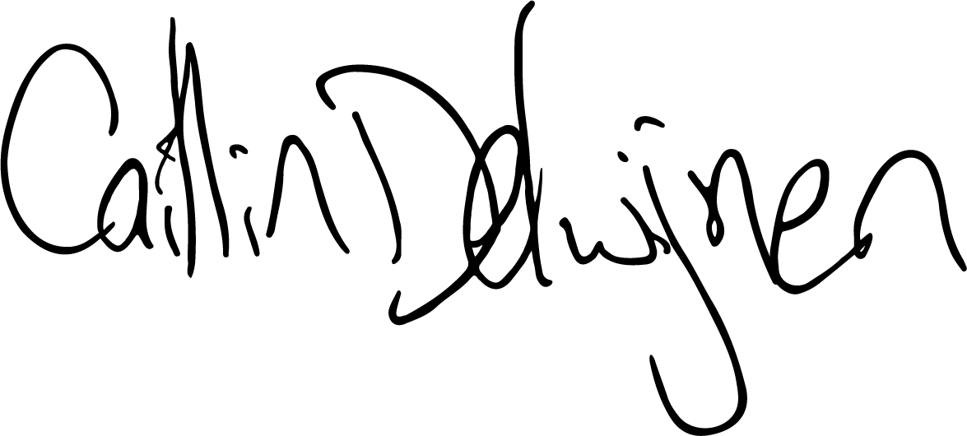
Caitlin de Cocq van Delwijnen
Principal Advocate, Queensland Advocacy for Inclusion
On behalf of the Queensland Independent Disability Advocacy Network (QIDAN)

https://qai.org.au/young-peoples-program/
Working together to deliver the NDIS - supporting analysis, pages 85-104.
Royal Commission into Violence, Abuse, Neglect and Exploitation of People with Disability, Governing for Inclusion – Final Report, Volume 5.

