29 July 2026

Tanya Plibersek
Minister for Social Services
House of Representatives
Parliament House
Canberra ACT 2600

Dear Tanya Plibersek,
Disability Aware and Inclusive Responses to Gender-Based Violence
The Queensland Independent Disability Advocacy Network (QIDAN) is a group of organisations funded under the Queensland Disability Advocacy Program to provide individual advocacy assistance to Queenslanders living with disability. QIDAN members offer various independent disability advocacy programs across Queensland, including supporting people with disability navigate Domestic, Family and Sexual Violence (DFSV) situations.
QIDAN welcomes the Australian Government's commitment to ending gender-based violence through the Second Action Plan (National Plan to End Violence against Women and Children 2022–2032) in response to recommendation 8.23 of the Royal Commission into Violence, Abuse, Neglect and Exploitation of People with Disability (the DRC) final report.
Over the past two years, QIDAN has led the DFSV and Disability Advocacy Project, a statewide project looking at the intersection of disability advocacy and DFSV. Through consultation with disability advocacy organisations, domestic and family violence services, government representatives and people with lived experience across Queensland, we heard that while there is a strong willingness to improve responses for people with disability, disability is often not embedded within mainstream domestic and family violence policy and practice.
Our project found that meaningful change requires:
- Disability awareness and inclusion to be embedded across domestic and family violence policy and practice from the outset.
- Genuine partnership with people with disability and disability advocacy organisations in the design, implementation and evaluation of reforms.
- Ongoing investment in workforce capability across both the disability and domestic and family violence sectors.
- Continued support for cross-sector collaboration to build relationships, shared understanding and coordinated responses.
Our Domestic and Family Violence and Disability Advocacy Project Report provides further evidence of the need for disability to be embedded throughout DFSV practice and policy, and recommendations based on consultation undertaken across Queensland.
We note the Disability Lens on the First Action Plan acknowledges the unique experiences of people with disability and the need for disability inclusive responses to DFSV. It states disability inclusion should be a central and ongoing priority of the National Plan rather than as a separate or subsequent piece of work. Yet, supports for people with disability are only mentioned briefly in the consultation paper, amongst a group referenced as “diverse populations”. We advise against grouping together people with disability, people from LGBTIQIA+SB communities, people from culturally and linguistically diverse communities and Aboriginal and Torres Strait Islander people as they all have different identities and needs.
We encourage the Australian Government to give greater visibility to the findings of the Disability Lens, ensuring people with disability are aware of and understand how it will be applied in practice. The Easy Read version is a valuable resource, however given the original documents length (almost 100 pages) we believe there is an opportunity to provide additional resources, such as general fact sheets or plain language fact sheets. These resources would assist people to understand the commitments within the Disability Lens, as well as how they relate to the Action Plan, and what they mean in practice. They would also support broader awareness and encourage meaningful engagement throughout implementation. The Second Action Plan consultation paper states that “important evidence and implementation gaps remain”, but it provides no reference to the progress of the Disability Lens implementation and what specific gaps have been identified. We hope our report mentioned above offers insight of existing gaps as per QIDAN’s experience. The lack of clear indication about the connection between the National Plan and the Disability Lens makes it difficult to assess whether the consultation questions have taken the Disability Lens into consideration. It is important that people consulted for the Disability Lens understand how the information provided has been used and how it has informed the current consultation.
Please do not hesitate to contact us if you have any questions. We can be contacted via email (saram@qai.org.au) or on 07 3844 4200.
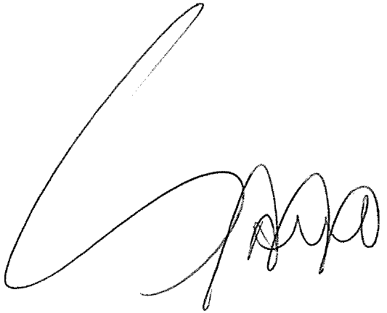
Your sincerely

Sara Martins, acting on behalf of Caitlin de Cocq van Delwijnen
Principal Advocate, Queensland Advocacy for Inclusion
On behalf of the Queensland Independent Disability Advocacy Network (QIDAN)

Australian Government, Department of Social Services, ‘Evidence to action: informing direction for the Second Action Plan – Consultation Paper in support of the National Plan End Violence against Women and Children 2022-2032’ (May 2026), p10.
Ibid.

