04 September 2025

Justice Hatcher
President Fair Work Commission
awards@fwc.gov.au

Dear Justice Hatcher
Re: AM2024/21 Gender-based undervaluation – priority awards review
- We write in response to the Fair Work Commission’s proposed new SCHADS classification structure and pay rates.
- Coordinated by Queensland Advocacy for Inclusion (QAI), the Queensland Independent Disability Advocacy Network (QIDAN) is a network of independent disability advocacy organisations in Queensland. QIDAN protects and promotes independent advocacy to uphold the rights, interests, and wellbeing of people with disability, ensuring socially just, accessible, and inclusive communities.
- We appreciate the Commission’s work to date in reviewing the SCHADS award and welcome the provisional view that the current SCHADS structure is not fit for purpose, simpler descriptors which are easy to apply at the workplace level are required, and the rates of pay applying in Schedule E are the subject for gender undervaluation.
- However, we are concerned that an unintended consequence of the proposed SCHADS classification structure, as outlined in paragraph [392] of the provisional decision, will significantly reduce the rates of pay for positions currently classified in schedules B and C. Queensland’s disability advocacy sector currently falls under schedule B of the SCHADS award, and the proposed changes will directly impact independent disability advocacy staff across the State.
- All QIDAN members are funded under the Queensland Disability Advocacy Program (QDAP), and some QIDAN members also receive funding through Commonwealth funding streams including the National Disability Advocacy Program (NDAP), and the NDIS Appeals Advocacy Program. Collectively, we provide individual advocacy assistance to over 1,500 Queenslanders with disability each year. Our work supports people to navigate complex systems (education, justice, child safety, housing, Centrelink, NDIS and more) to access services, supports and the community, engage in appeals and complaints processes, express their views, and address discrimination or unfair treatment. Advocates provide information, options and support so that people with disability can make informed decisions. They have a breadth of skills and specialist knowledge of systems and legislation. At a minimum advocates need to exercise initiative, work autonomously and be highly skilled communicators and negotiators.
- In addition to individual advocacy, QIDAN members work together to address systemic issues experienced by people with disability. This includes contributing to disability reform, providing advice to government and building awareness through community education. More information about our work can be found on our website https://disabilitypathways.org.au/.
- Queensland’s independent disability advocacy sector employs approximately 130 people across administrative, advocacy, legal, and management roles under the SCHADS Award. The National Centre for Disability Advocacy, Advocacy Sector Workforce Survey 2024 demonstrates that the advocacy sector workforce in Australia is both diverse and highly skilled:
- 75% of staff identify as women
- 16% are culturally and linguistically diverse
- 5% are First Nations people
- 33% are people with disability
- 37% are unpaid carers for a person with disability, and
- 15% both live with disability and provide informal care.
- In terms of qualifications, 55% of workers hold a bachelor’s degree or higher, and 77% hold a Diploma or higher qualification. Common qualifications include Diplomas in Community Services or Disability, as well as degrees in Social Work, Law, Education and Social Science. Importantly, the workforce also values lived experience, which is as critical as formal qualifications in advocacy roles.
- The survey indicates that 65% of staff perform multiple roles within their organisations, highlighting the breadth of skills required and the resource constraints our sector operates under. While recent funding uplifts have expanded staffing, 75% of workers have 5 years’ experience or less, demonstrating growth and turnover.
- Workforce data highlights significant challenges in attracting and retaining staff:
- 71% of organisations report difficulties recruiting, citing lack of experience, skill shortages, rural and remote workforce gaps, limited job security, and uncompetitive salaries.
- 57% of workers report completing more than 10 hours of unpaid work per week
- 42% report that their work impacts their health and wellbeing daily
- 54% plan to leave, or an unsure about remaining in the sector, within the next 6-12 months.
- This is already a workforce under strain. Any reduction in pay rates would intensify these pressures, further reducing the sector’s ability to deliver essential advocacy services to people with disability.
- QIDAN strongly supports the Commission’s objective of addressing gender-based undervaluation. However, we are concerned that the provisional decision risks producing the opposite outcome. By lowering rates of pay for future employees in roles currently classified under Scheduled B and C, the provisional structure risks entrenching undervaluation and creating a two-tier workforce. New entrants could be paid less for performing the same work as existing employees, undermining pay equity and worker mobility. This risk is heightened in a sector characterised by a transient workforce due to the prevalence of short-term, government-funded contracts—a reality already acknowledged through the introduction of portable long service leave.
- For example, under the provisional decision the proposed SCHADS Level 5.1 weekly rate is $1,422.18 compared with the current rate of $1,938.00 – a reduction of nearly 30%. This represents a significant devaluation of professional and skilled advocacy roles. For organisations such as ours, where the majority of experienced staff are employed at Level 5 and wages account for more than 80% of expenditure, such a change would not only undermine workforce attraction and retention but also distort tender processes. Government purchasers of services could expect new contracts to be delivered at substantially lower staffing costs, while organisations that seek to minimise pay disparities between existing and new employees would be left uncompetitive. In practice, this risks driving down funding to levels that prevent us from employing a skilled and experienced workforce, leaving the sector reliant on underqualified staff and eroding the quality of advocacy support available to people with disability.
- The Equal Remuneration Order outcomes must be preserved, reducing baseline rates would undo more than a decade of progress and exacerbate recruitment and retention difficulties. The breadth and complexity of advocacy roles, spanning systemic reform, legal advocacy, complex case support, project coordination, and cultural expertise, are not adequately reflected if the sector is pegged to caring work alone.
- The Disability Royal Commission and the National Disability Insurance Scheme Review both highlighted the critical importance of independent advocacy, and wages must reflect this significant positive net economic benefit. The DRC noted the following benefits delivered by advocates:
- avoid and reduce costs for governments
- increase life satisfaction for people who receive services
- more productive employment for people with disability
- better educational outcomes for people with disability
- better health outcomes for people with disability
- better child protection outcomes for people with disability.
- Our sector exists to empower people with disability, resolve issues, and challenge discrimination. Staff report that what sustains them is the ability to make a positive difference. However, they also report daily challenges of managing unmet demand for services, increasing case complexity and the inaccessibility of systems. Lowering pay rates would jeopardise the sustainability of advocacy organisations, limit our capacity to recruit and retain skilled staff, and ultimately reduce the availability of advocacy support to people with disability. This risks rolling back progress made under both state and federal disability reforms.
- We note the Commission’s assurance that existing employees will not have their pay reduced in the transition to a new structure. However, as outlined above, allowing reduced rates for new entrants is unsustainable and inequitable.
- To ensure a fair and workable transition, any new structure must:
- be accompanied by a clear and transparent process for translating existing positions.
- give organisations adequate time to review and revise position descriptions, update industrial instruments, and adjust budgets in line with the new framework.
- In addition, Governments, who are the primary funders of advocacy organisations, must provide guarantees that they will meet the cost of any new wage rates and support the sector through the transition. Without this commitment, the changes cannot be practically or sustainably implemented.
- QIDAN urges the Commission to:
- Protect existing Equal Remuneration Order outcomes by using them as a baseline for new wage rates, ensuring no current or future employee is paid less for the same work.
- Recognise and properly value the diversity and complexity of community advocacy work, rather than narrowing its scope to “caring work”.
- Require governments, as the principal funders, to guarantee adequate funding and support for organisations to implement any new wage structure though a clear and sustainable transition process.
Only through these measures can the Commission’s objectives of addressing gender-based undervaluation and ensuring fair, sustainable wages for our sector be achieved.
Yours sincerely
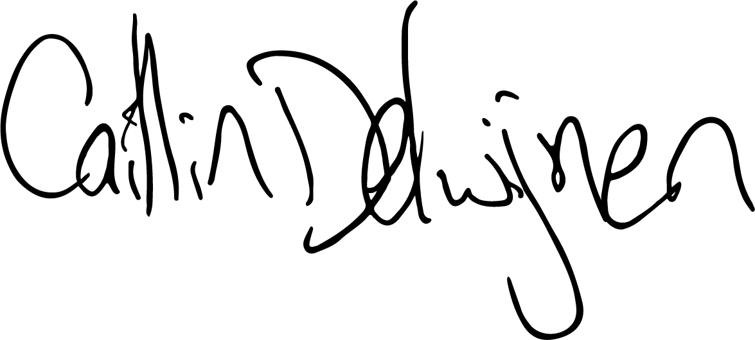
Caitlin de Cocq van Delwijnen
Principal Advocate, Queensland Advocacy for Inclusion
On behalf of the Queensland Independent Disability Advocacy Network (QIDAN)

National Centre for Disability Advocacy, Advocacy Sector Workforce Survey 2024 Results Report, June 2025, https://ncda.org.au/wp-content/uploads/2025/07/Advocacy-Workforce-Survey-Results-2025-final-1.0.pdf
Royal Commission into Violence, Abuse, Neglect and Exploitation of People with Disability (2023). Enabling autonomy and access. Pg. 255. Retrieved from https://disability.royalcommission.gov.au/publications/final-report-volume-6-enabling-autonomy-and-access p255
National Disability Insurance Scheme (2023). NDIS Review: working together to deliver the NDIS. Pg. 57. Retrieved from https://www.ndisreview.gov.au/resources/reports/working-together-deliver-ndis pg. 57

